[Pandas_Cheat_Sheet.pdf (pydata.org)](https://pandas.pydata.org/Pandas_Cheat_Sheet.pdf)

Parent child

Parent: primary key

Child has – foreign key reference to primary key in parent

Child table- foreign key

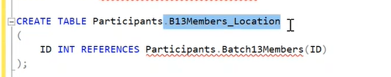

Other way of creating foreign key in child table

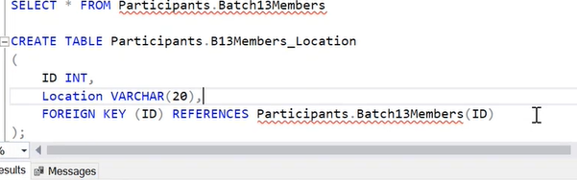

Identity key or id is to identify every record uniquely in a table

Or

Location of a record in a table

Every table must have id column

--- I cant insert a record in child table if parent table has no such record

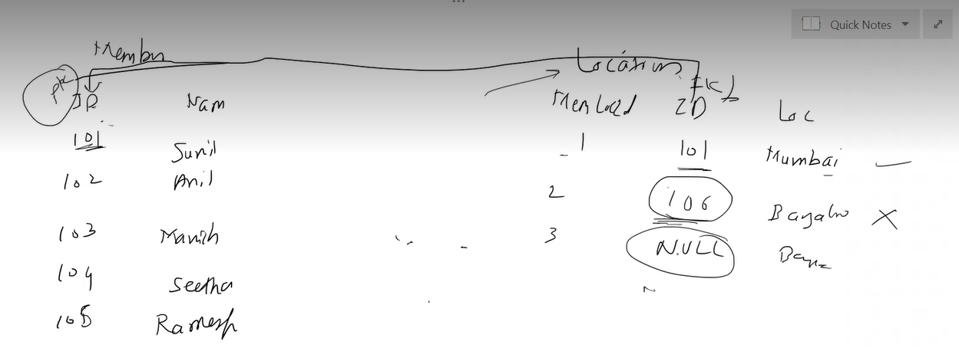

Foreign key accept null values

When you dot want foreign key should not allow null vales

Use below

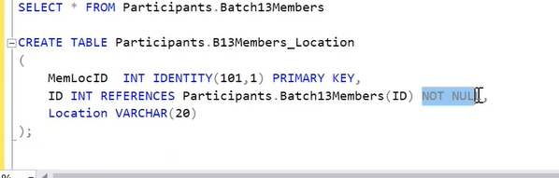

Data from parent table referred by child table

Child is dependent table

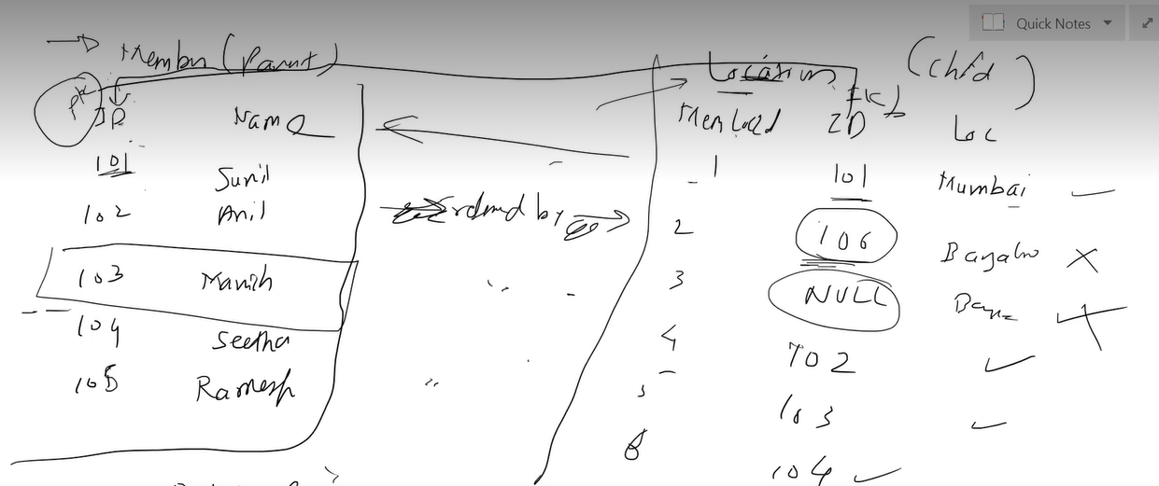

If parent record is referred by child record we cant delete record in parent table unless it is deleted in child record

If record is not referred by child can delete in parent table

--

3 options we can use in child table to delete a record in parent table can automatically deletes in child table

We need to mention in child table

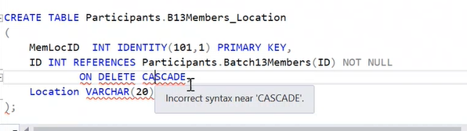

On deleting parent record- child record converts to null record.

There s no use of having null record

Better to use cascade

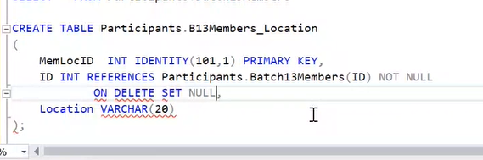

--

On delete set default

One deleting record in parent table will change that record in child table to default value

For this there is pre- requisite that , that column must have default value

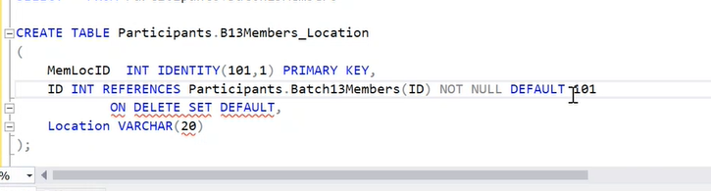

Above one is also used for update also

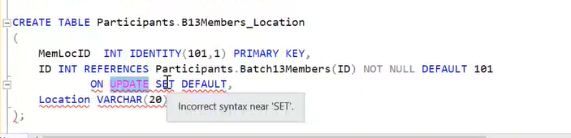

On update cascade

On update set null

On update set default

Condition : where

Filter : where

--------------------------------

NULL;

WHERE COLUMN IS NULL

WHERE COLUMN IS NOT NULL

BUT WE WILL NOT USE =,-, FOR NULL VALUES

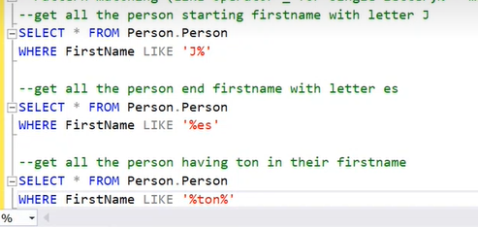

STARTS WITH D

ENDS WITH N

BETWEEN CAN HAVE ANY CHARACTER BETWEEN A TO H(ONLY ONE CHARACTER)

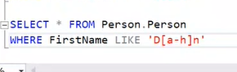

STARTS WITH D

ENDS WITH N

BETWEEN CAN HAVE ANY CHARACTERS BETWEEN A TO H(ANY NUMBER OF CHARACTERS)

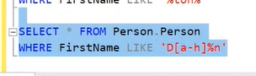

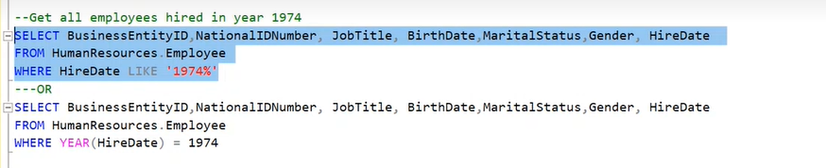

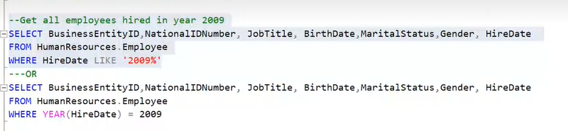

We can use like operator on date type data type

Rather than using string – like function

Better to use functions

YEAR(HIREDATE)—give optimal and speed results

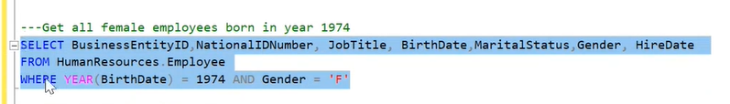

Replacing null values

First write query

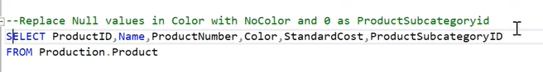

Beside that column with null values

ISNULL(colour, “no colour”)

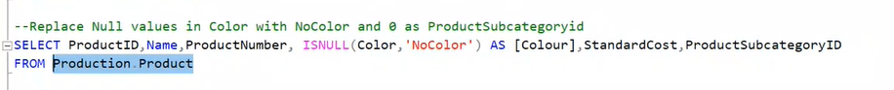

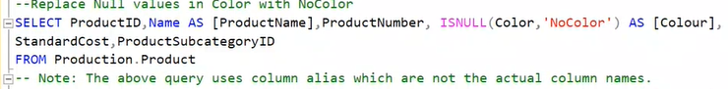

Alias names will not be worked on where

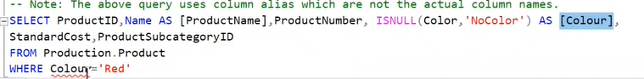

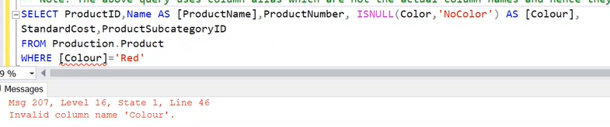

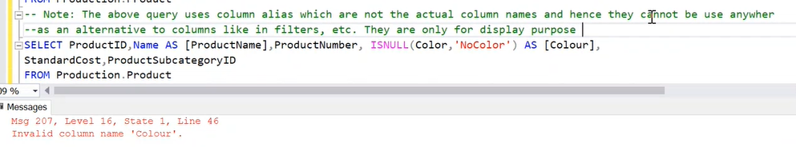

Case

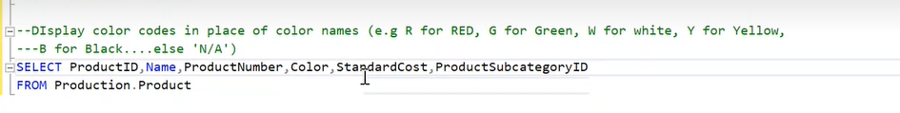

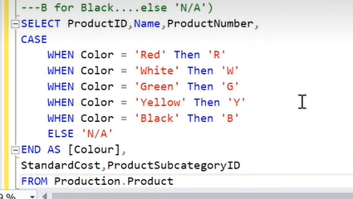

Built in function

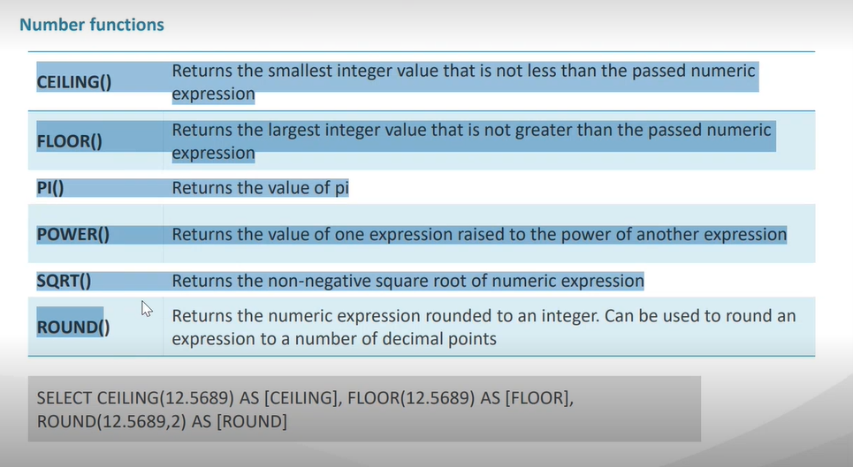

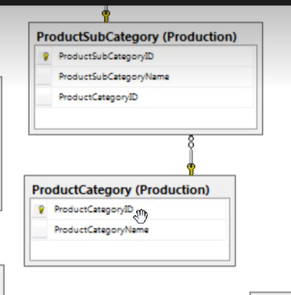

If golden key attached is a parent table

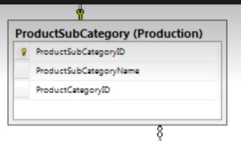

Infinity is foreign key (child table)

String functions

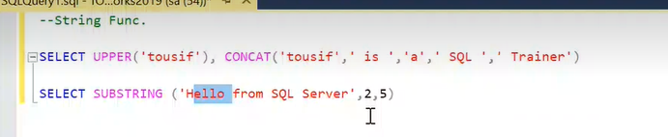

Index in sql starts from 1

Substring( index where to start, number of words)

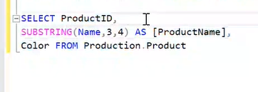

Get date is current date

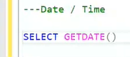

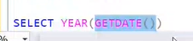

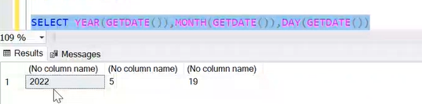

Adddate add number of years to get date

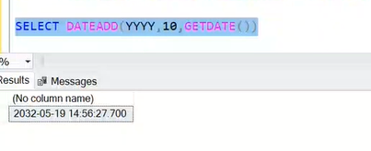

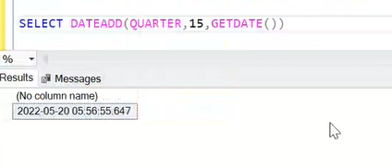

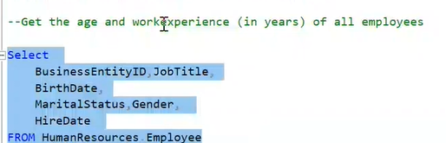

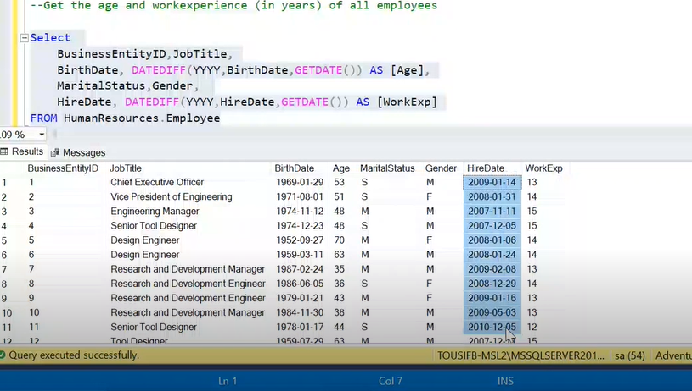

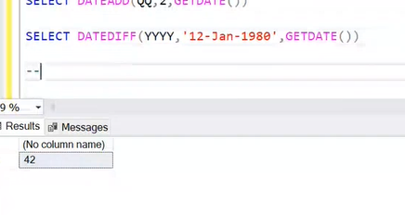

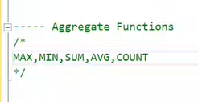

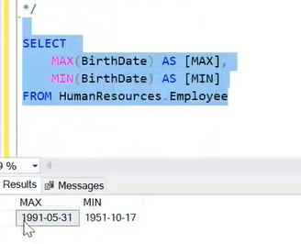

Youngest employee – max(birthdate)

Or we can do datediff- find age

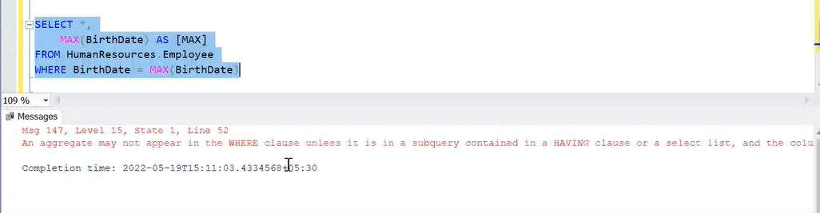

We got error

When we apply aggregate function all records in a table is converted to a single group, when we apply aggregation the result will be a single scalar value

As a movement we got single value we have no longer have access to single column and values

That’s why * didn’t work

And also when we try to filter rows by using where we don’t have access to single rows or individual rows it didn’t work as we don’t have access

--- solu- subquery

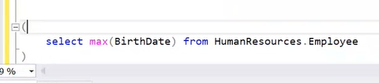

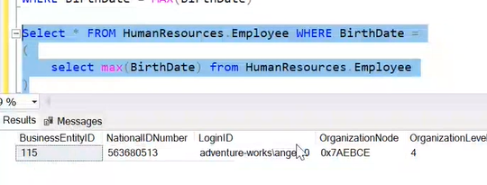

Its based on business case

When we just want max –

Select max(birthdate) from table

Along with max if we want other infor- business requirement is diff

It wont give other info like column names and data

All aggregate function groups entire data and give scalar value

It wont give other information

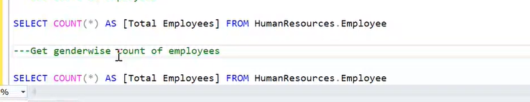

Genderwise means we need to create won groups- then use groupby

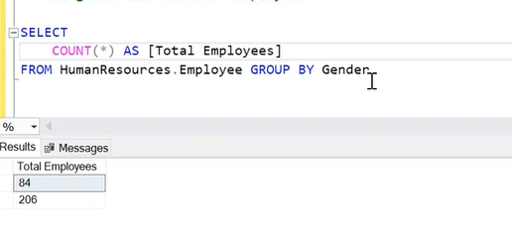

It just gives values

To get whose values related to

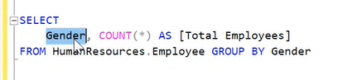

Here gender is not regular columns

Here gender refers to group

Since on gender we are using we can access that

But still other inviduals columns and rows cant be accessed

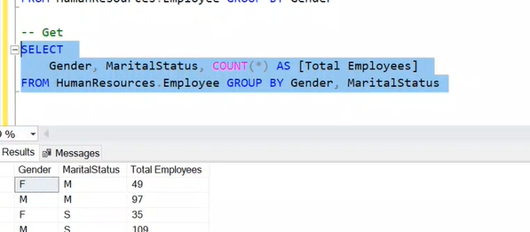

When we are working with groups

We cant use where

Only having

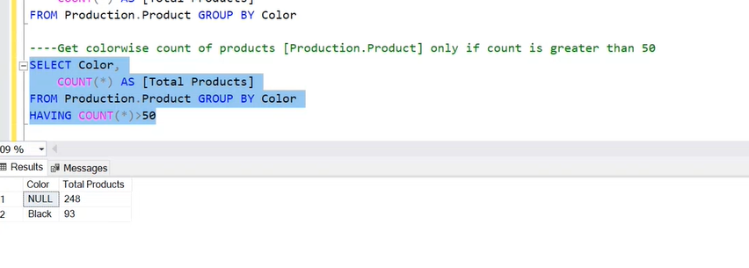

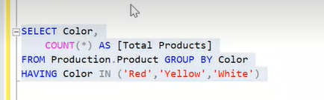

Above will work as its filter based on groups only

Can we get total aggregation and all rows together – no

Once we used aggregation we cant access to individual records

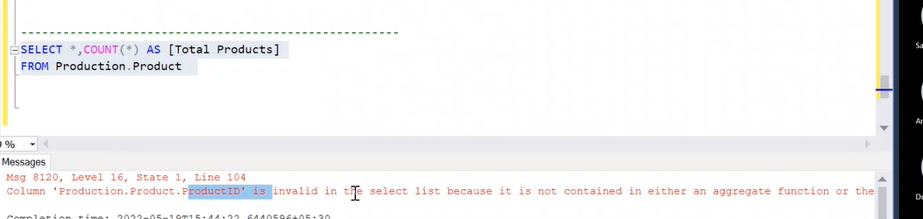

We can do that by using over() on the count function -

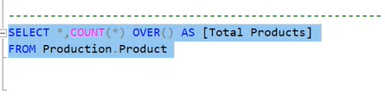

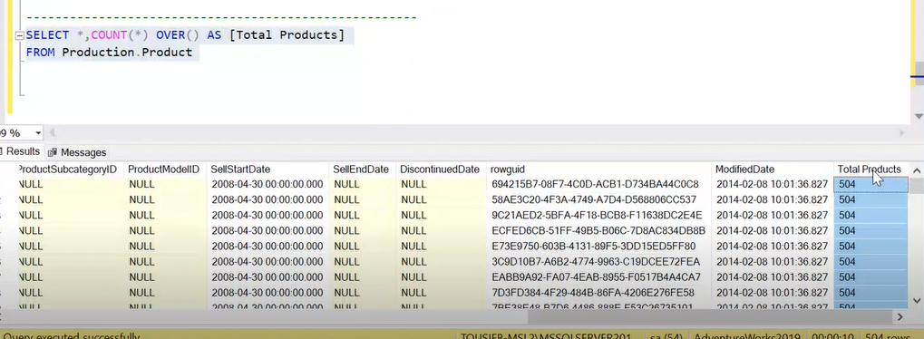

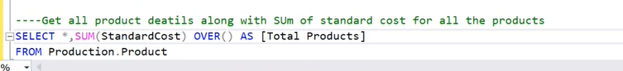

When we want only specific columns

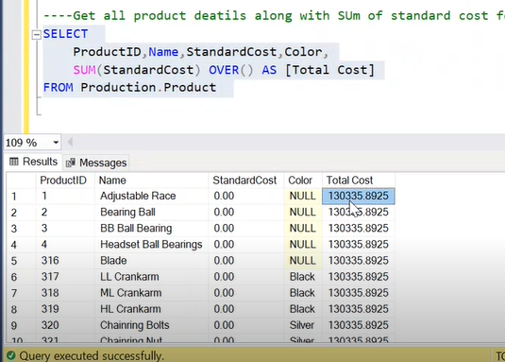

Over() clause called as window function – to create multiple partitions

When we use partitions we can still have access to individual columns

Even without using partition word –

Over() default do one partition

Partition – parameter

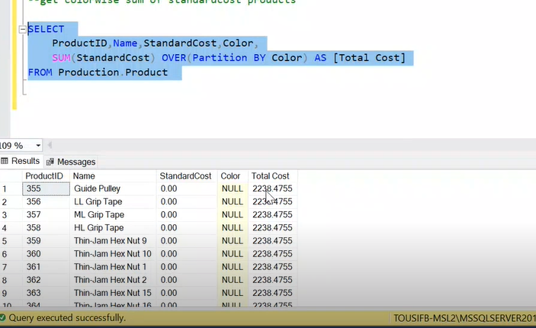

Over with out parameter : total table as one partition

Over with parameter – partition based on one of column

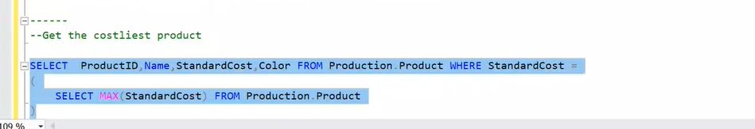

Numbering ordering , ranking

2nd best employee

3rd best

Or bottom 25 percent worst performance

So ranking function came to picture not orderby limit

Ranking function assign ranks to every record in a table or a partition

4 ranking functions

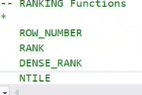

First write normal query



Pre requisite for ranking is sorting data



Row_number() function assign unique name to each row

Ranking function must be used along with over()

Then write on what basis we assign rank

Your data must be sorted

Where it should be sorted : in over clause

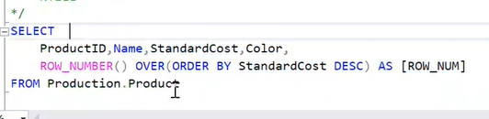

First it sorted data based on standard cost

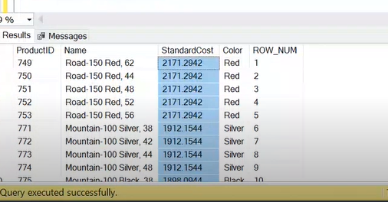

Then gave row number uniquely

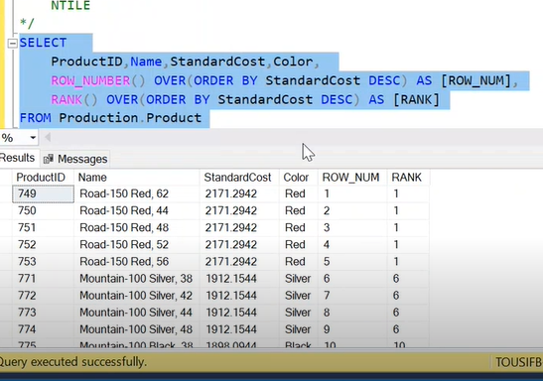

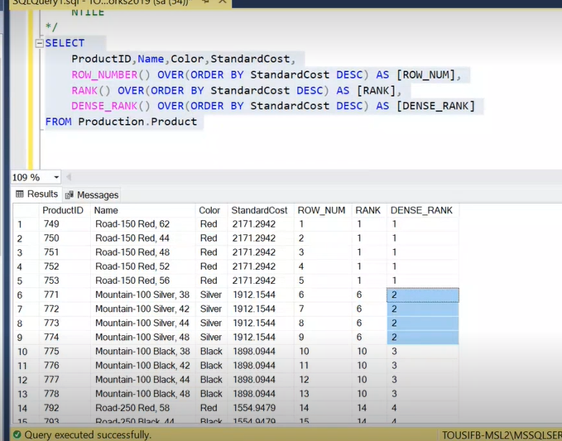

2nd costliest product

We do partition

Every partition will get separate ranking

**Give us 2nd costliest product in every colour**

for this we need to partition by colour

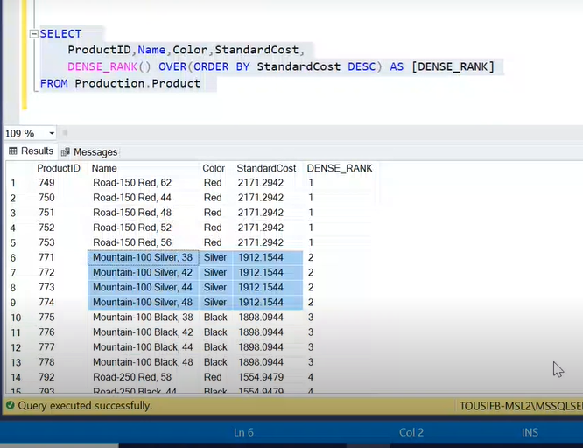

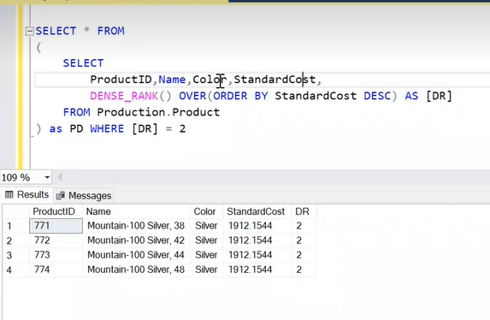

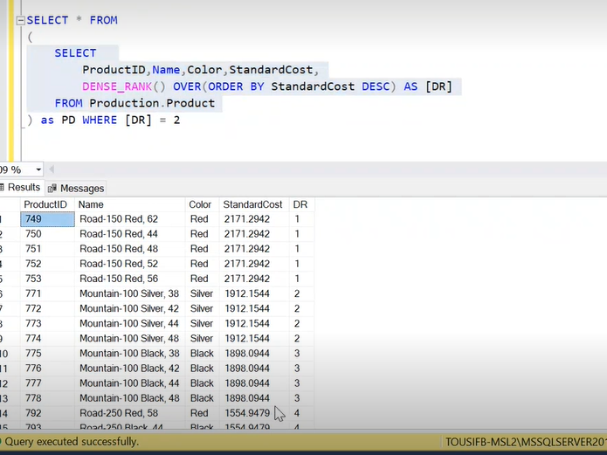

Middle query is derived table

Instead of table I have written an another query which results table (customizing table)- this concept is called – derived table

3rd costliest

Where dr=3

2nd costliest in every colour

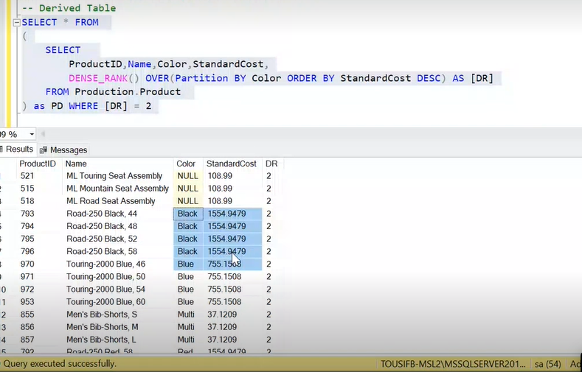

Ntile:

Above 3 function don’t take parameter

But ntile takes parameter

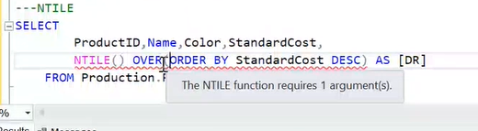

Giving error since ntile needs an argument

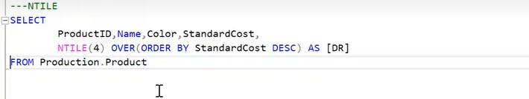

Ntile groups into 4 groups

It equally distribute all records into groups

-----------------------------------

If we do partition with ntile

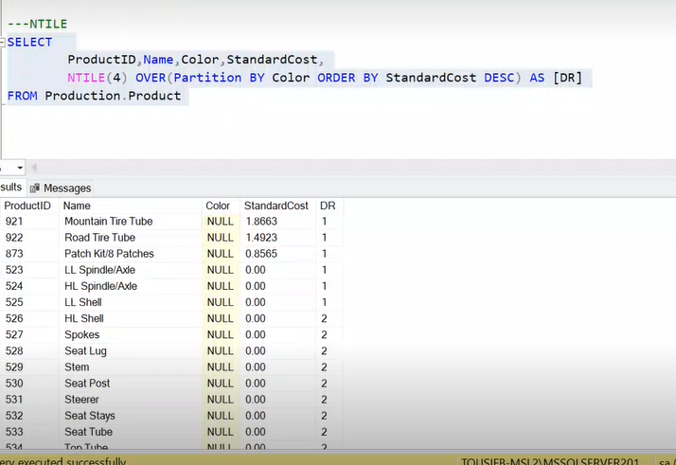

It does 4 partitions within every colour

Citius tech wants to distribute 50k to top 25% of employees

Ntile( 4 )- order by ratings in appraisals

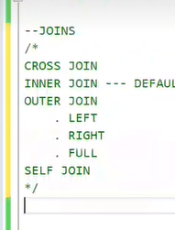

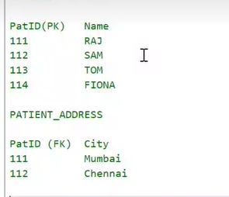

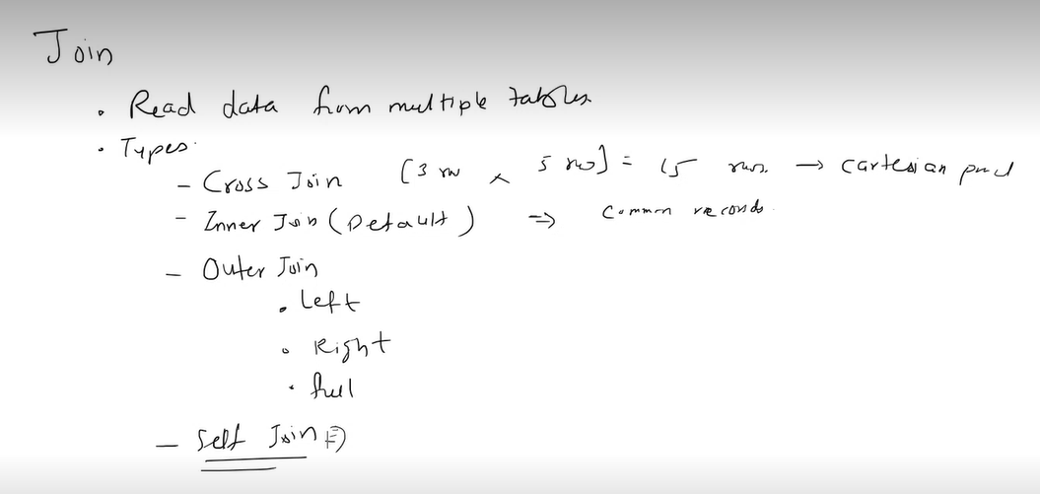

Self join :

Why should we join self join for table

If columns in table are related to each other or if there is relationship between columns in same table

Employee example

Emp id , name of employee, manager id

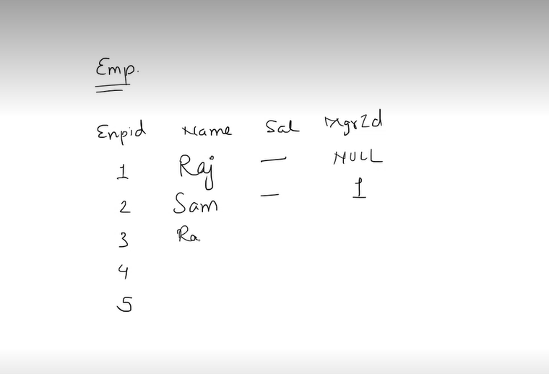

Sam manager is id 1 that is raj

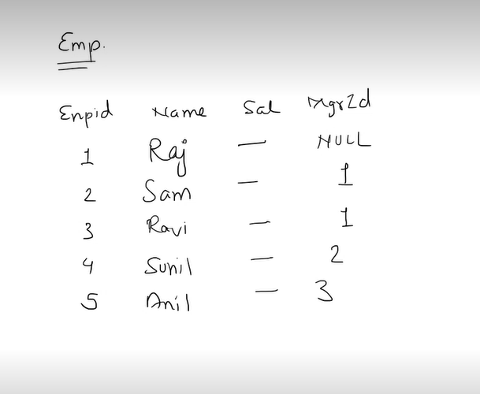

If business req is get the names of employees along with their manager names

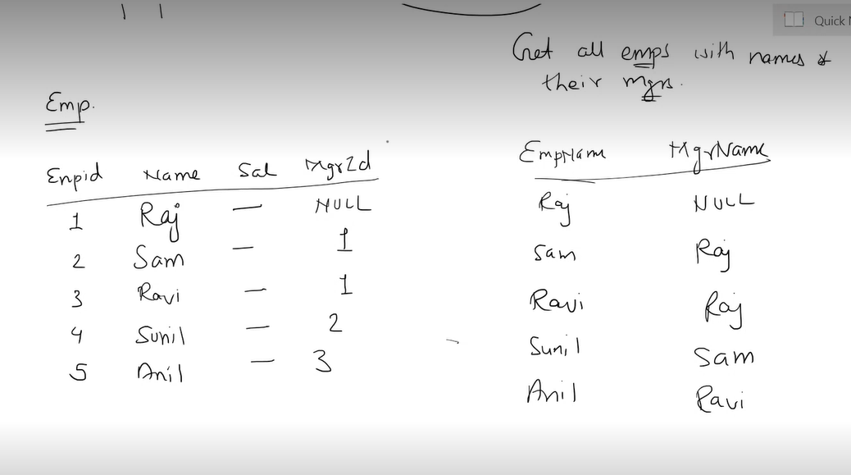

Manager id is like kind of foreign key refers to emp id

We assume two tables

Think one table as emp

Other table as manager table

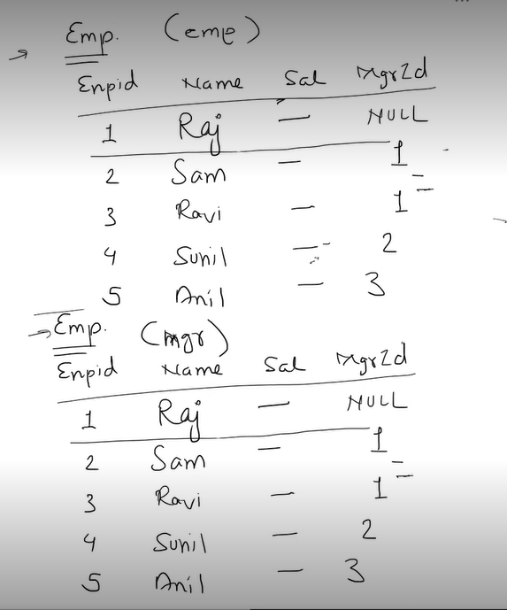

Emp id in managertable is primary is referred to manager is table in emp table

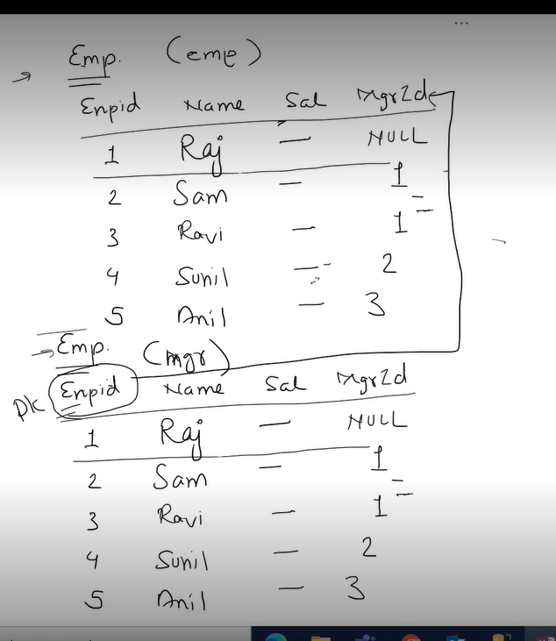

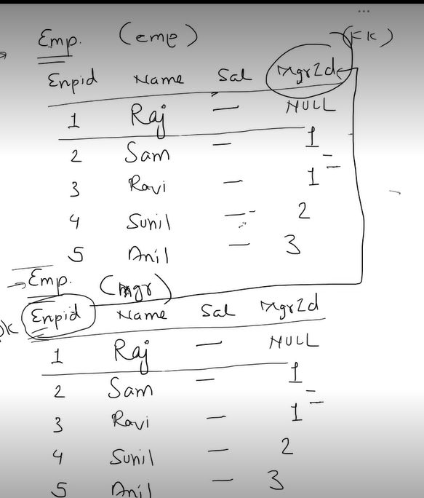

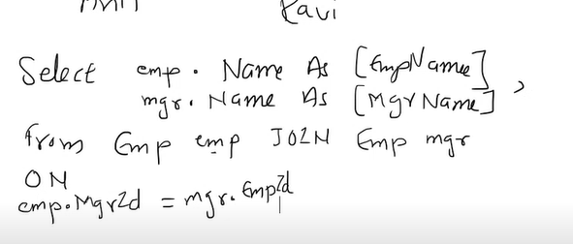

3 tables

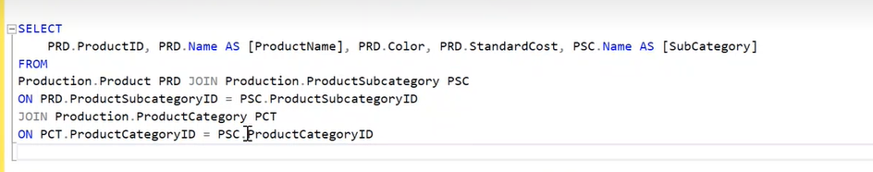

You should keep joining

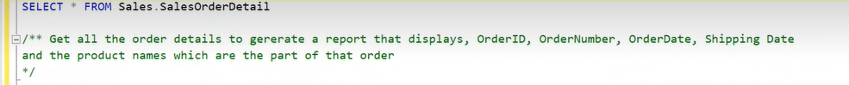

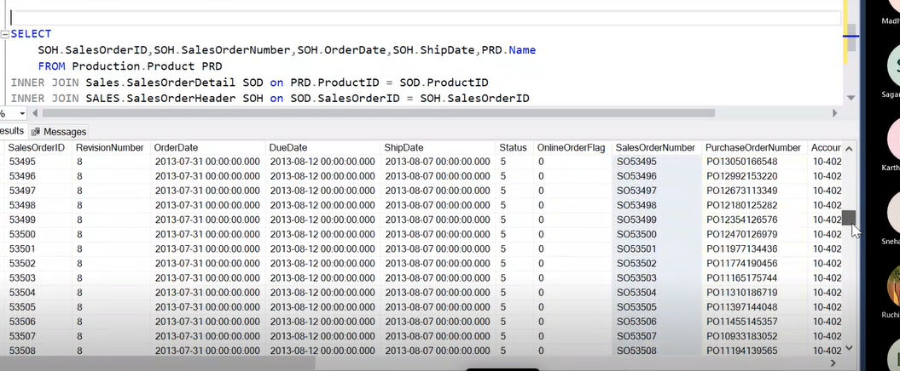

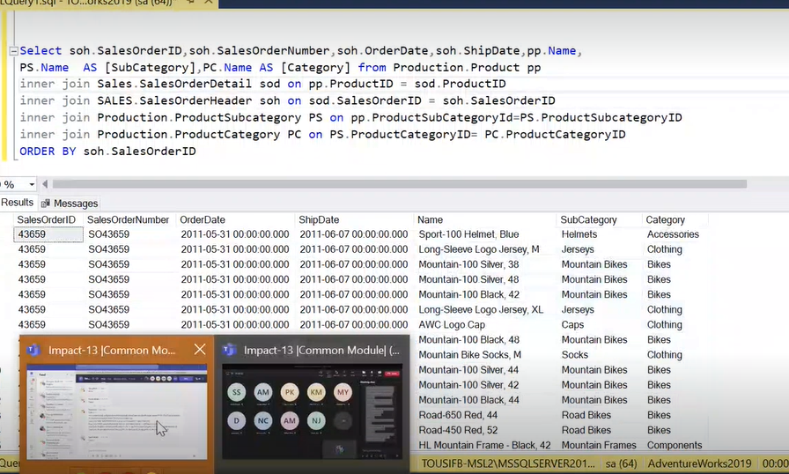

SUB QUERY

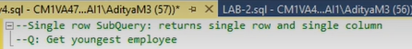



Max aggregate function gives only scalar value

So used that in sub query

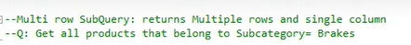



Outer query needs only records based on product subcategory id , so sub query should have only that column in select list



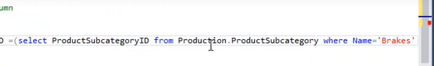

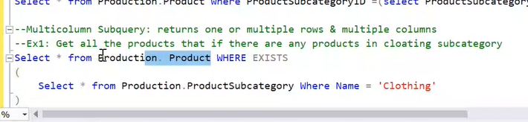

Exist check if there is data—

If there are subcategories in clothing will give result

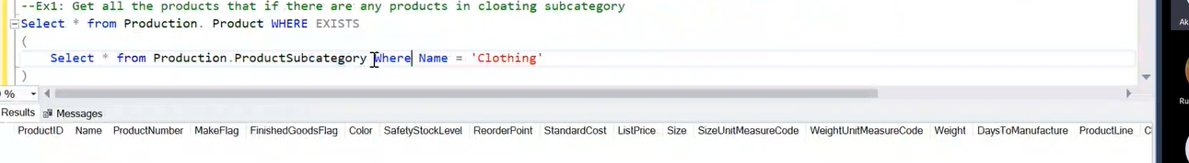

Since there are no sub category in clothing will get above

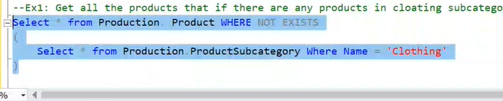

Not exist ; all categories which don’t have clothing

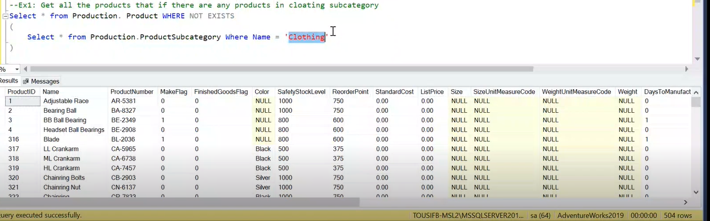

Query – sub query

Functions

Triggers

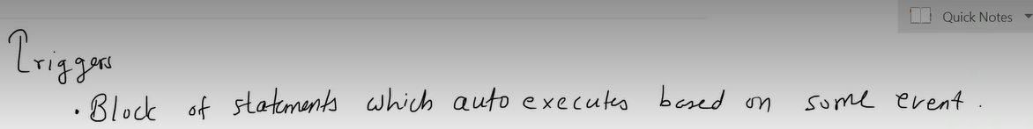

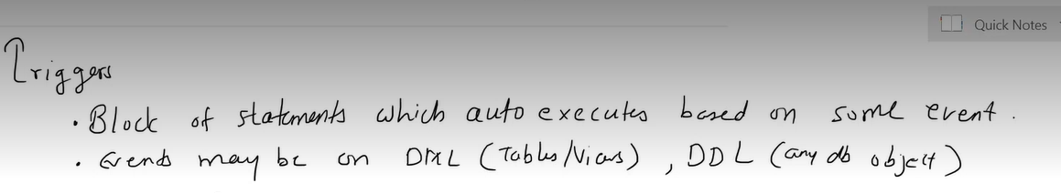

Database objects like procedures, tables , views , multiple data bases



Index

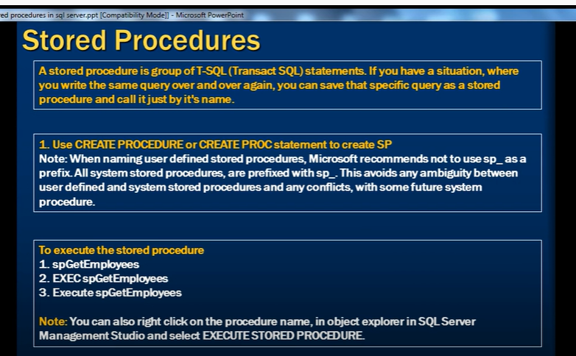

When we have to repeat same query again and again

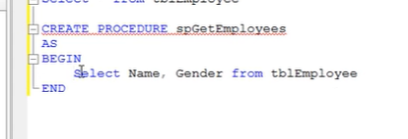

Or create proc

--

It will be stored in database

Refresh in stored procedure

--

Execute

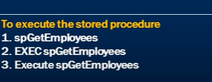

---

When I want to create stored procedure with parameter

Ex employees by gender and dept

We need to pass parameters gender parameter and dept id

Gender is string- varchar

Dept id int

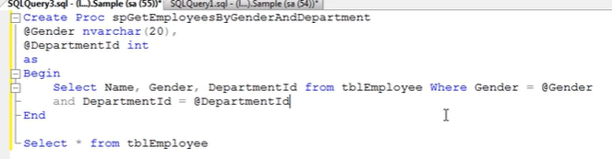

While calling procedure or executing procedure

We need to pass parameters

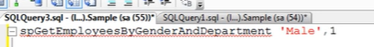

--

What if I pass in

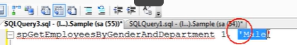

It fais becoz first parameter is gender

--

When we have multiple parameters it should in order

--

To avoid that



--

How to know scrip of stored procedure

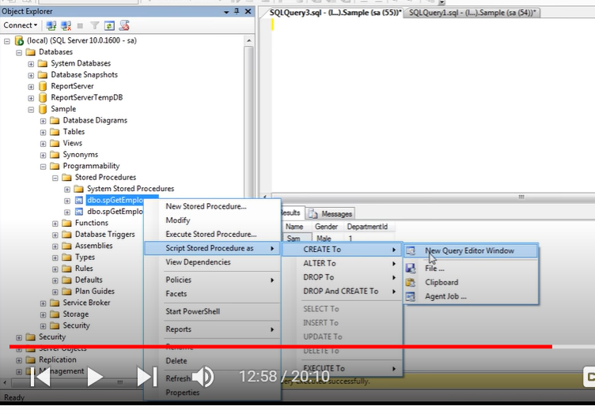

What we have created is user defined stored procedure

Sql server has its own system generated stored procedures

Name of sys stored procedure

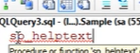

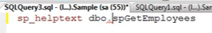

Write user defined stored procedure besides it

Select together

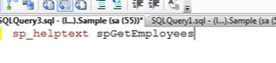

Select together and execute

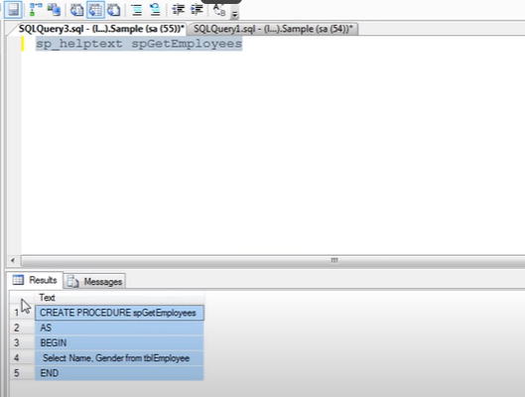

We get text of stored procedure below

Copy it and paste in ur window

For user defined stored procedure we cant use SP_

After creating stored procedure we want to alter or change

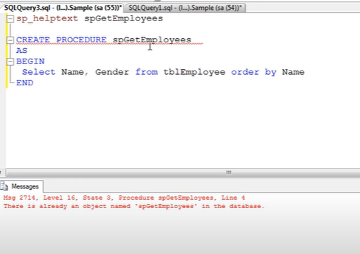

We get error

We should use this

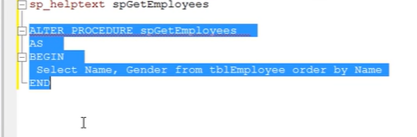

Delete

Drop procedure procedure name

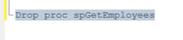

Encrypt text of stored procedure

With encryption

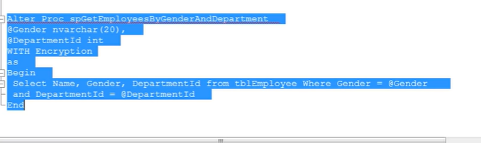

**Stored procedures with output parameters**

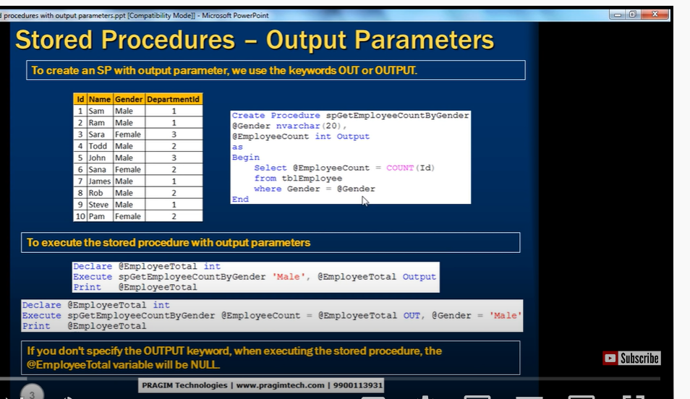

Int output

Gives us output in int

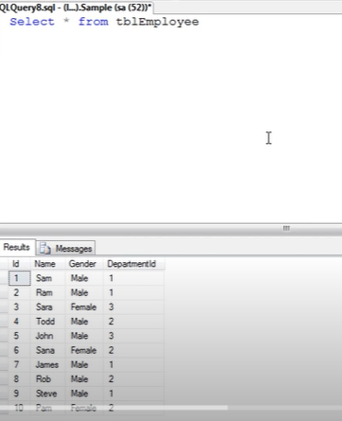

We need to get count of employee

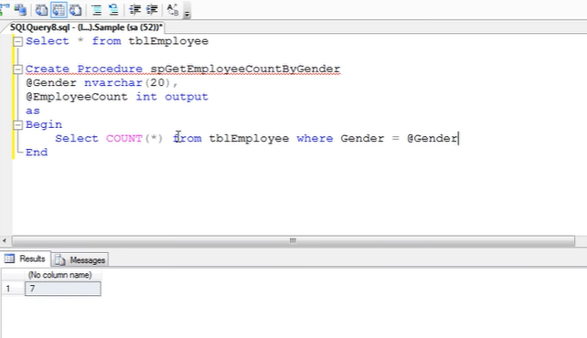

We should initialize output parameter

@Employeecount

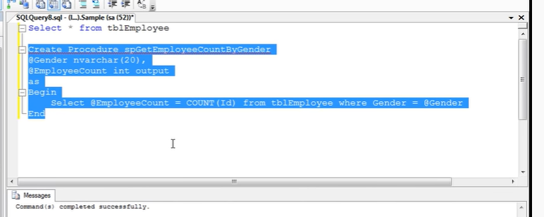

Now execute stored procedure with output parameter

Now its accepting 2 parameters

1. Input parameter – gender
2. Output parameter

Output parameter generates some output or return something back to u. we need to hold some where, so we need to create some variable to store output



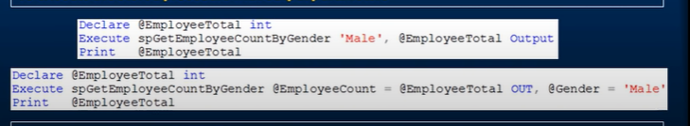

First we need to declare output

Then execute name of stored procedure , keep parameters (input value) for output we need to send variable to receive value along without output

Variable is @EmployeeTotal



Finally we need to print output

Print @EmployeeTotal

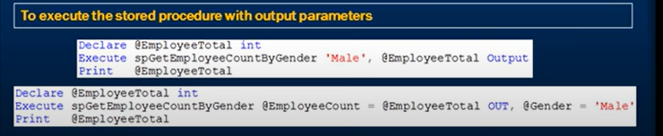

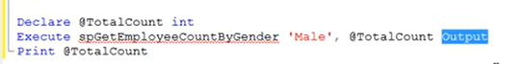

If I don’t use output word,

It wont print anything

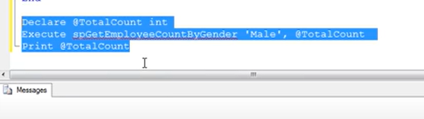

Because @Totalcount will not receive any value – the value becomes null

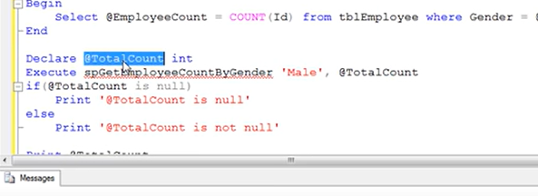

When u use output

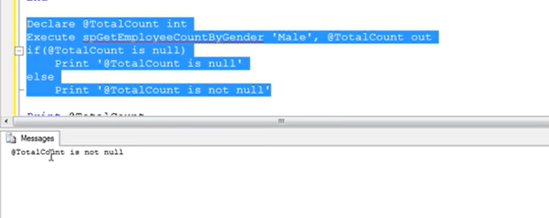



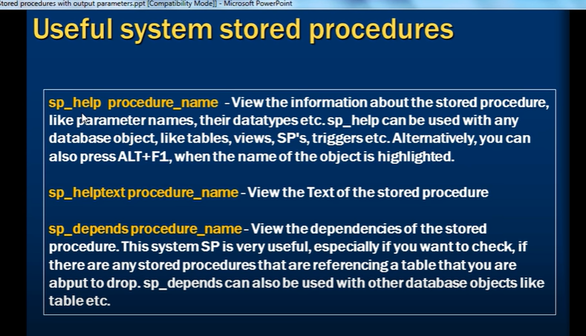

SP_help Procedure name

To view info above stored procedures

Parameters names

Datatypes of parametes

Database objects like tables, views, sp , triggers



To view text of SP

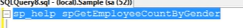

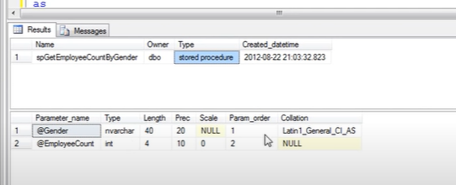

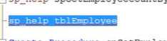

Sp_help table name

Which gives all the information of a table

SP_HELP: can view any information of any database object

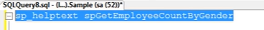

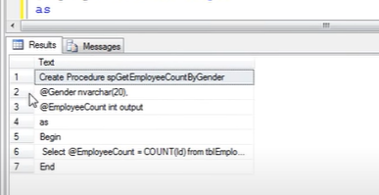

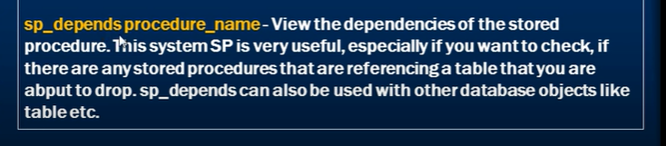

Used to see dependencies of stored procedures

Like if it depends on tables , columns

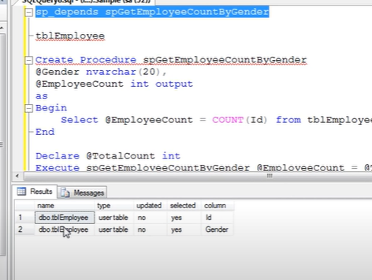

When I am deleting table , it wil get error

--

Even to check if any other objects depends on the table

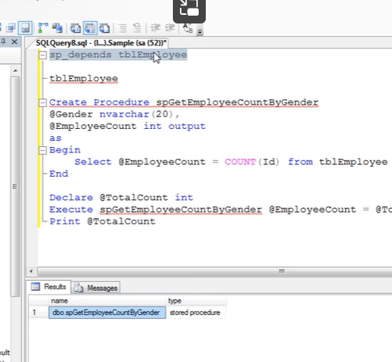

Sp_depends table name

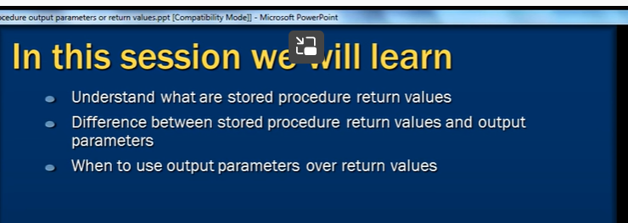

Return values

Whenever we 

It returns integer status variable

1. Success

Non zero – failure

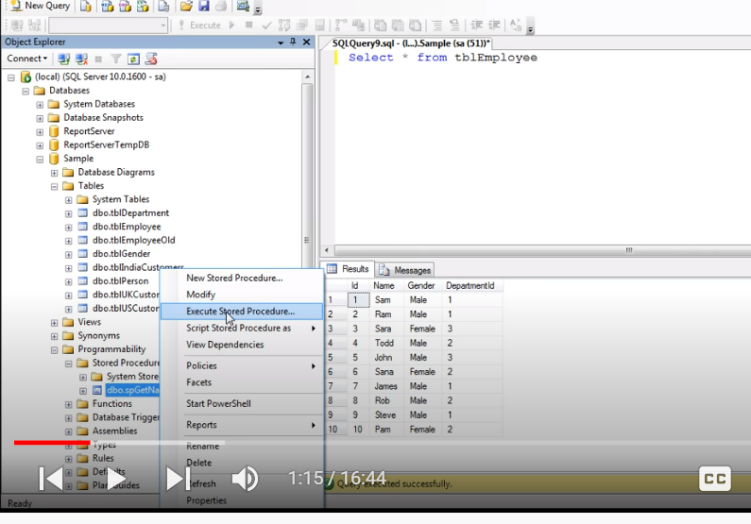

This window will open

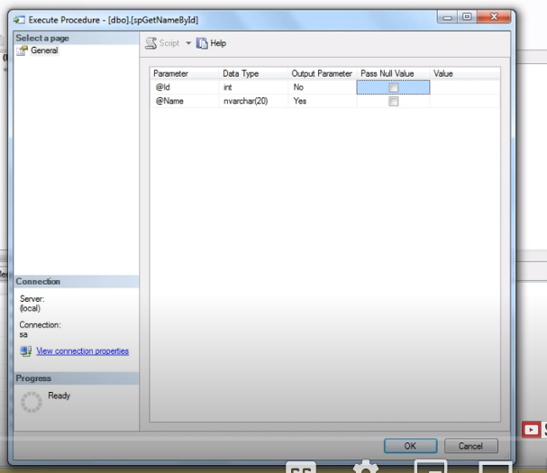

Provided id =1

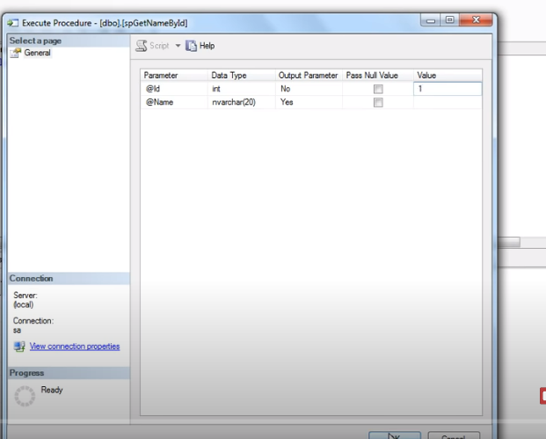

Stored procedure got executed

Returned

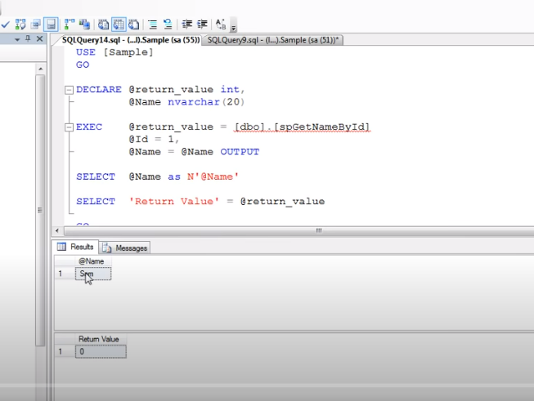

Return value “0” – indicates success

Integer status value

Difference between return value and output parameter

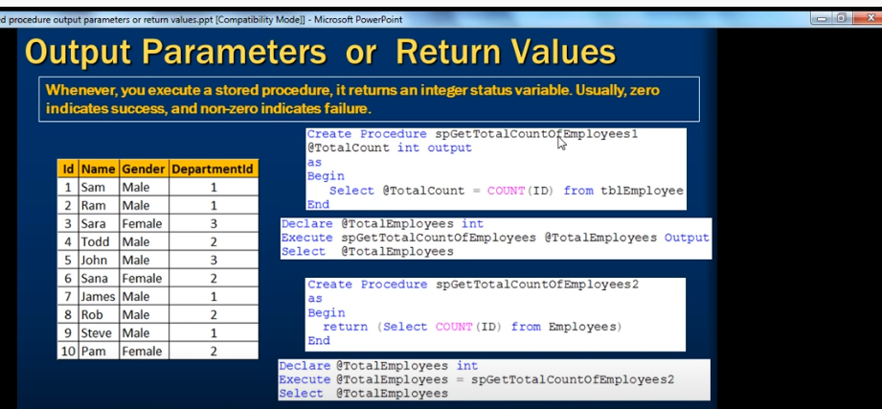

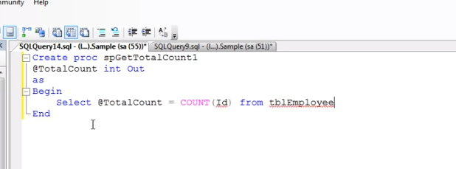

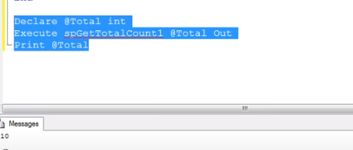

Using return keyword

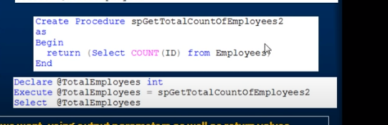

When return statement used no use of output word

--

Where return used or output parameter

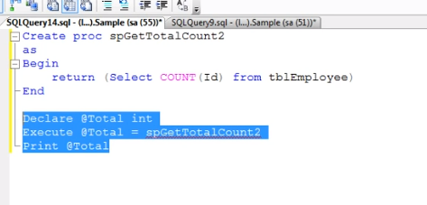

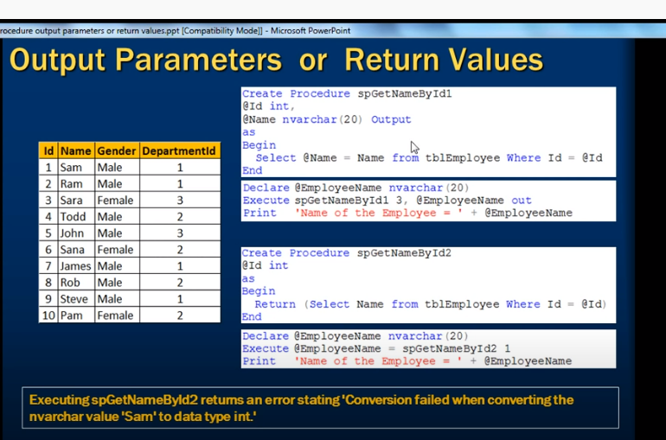

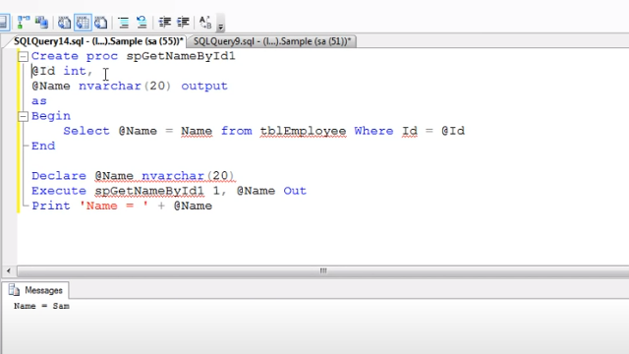

Return

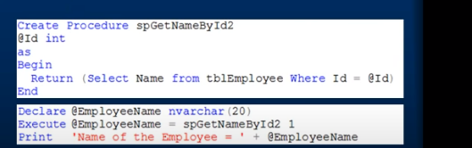

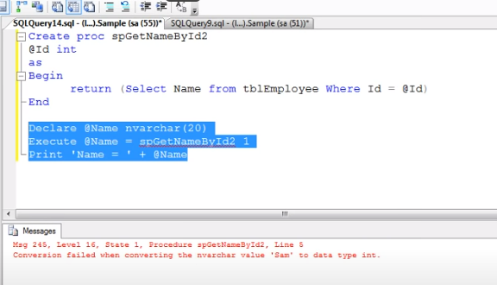

But failed

Return value of stored procedure should be always zero

But we are trying to return varchar

Though it got executed while creating stored procedure

But while executing it wont as it convert varchar to int

And return value must be only one

Like u cant return age and pincode

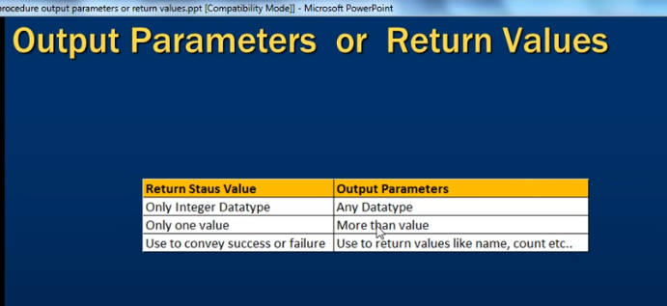

Advantages of stored procedure:

Reusing of execution plan( for query to execute which way will be benefit )

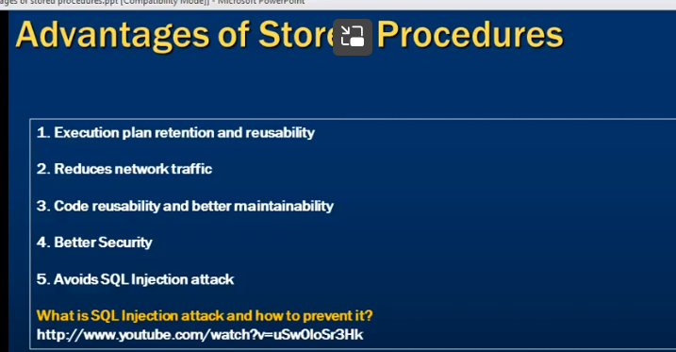

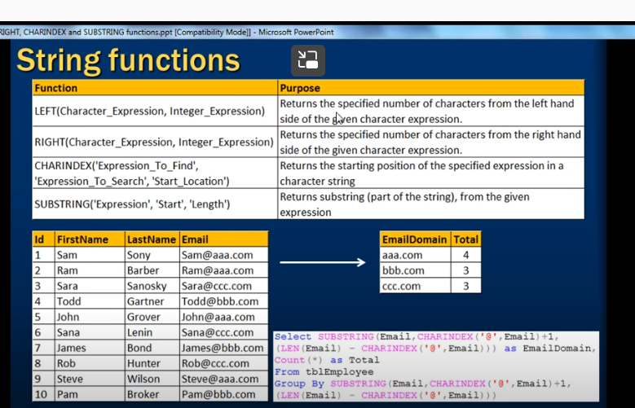

Left

Character_ expression= string

Integer_expression : number of character



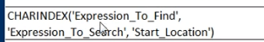

Expression to find: what to search , @

Expression to search: string / character/ column name

Start_location: if many number of expressions in character , 1 means 1st occurrence

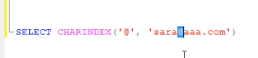

Substring :

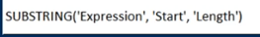

Part of a string

Character, where do u want to start, howmany words

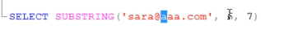

Different mail id has @ at different positions

So

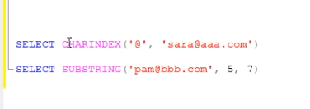

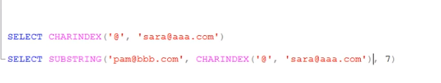

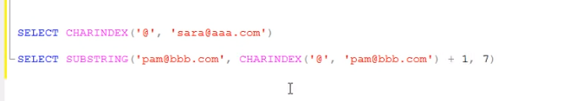

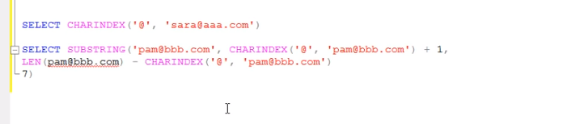

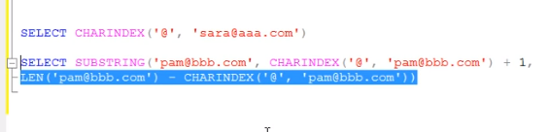

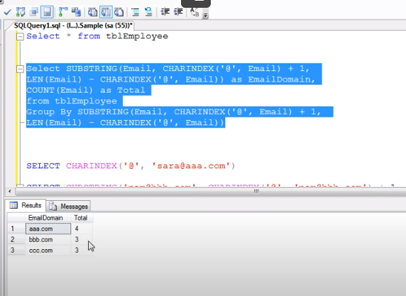

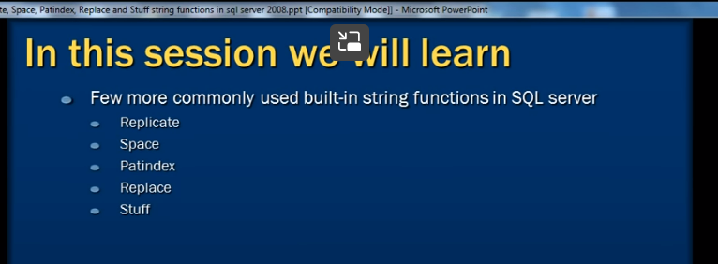

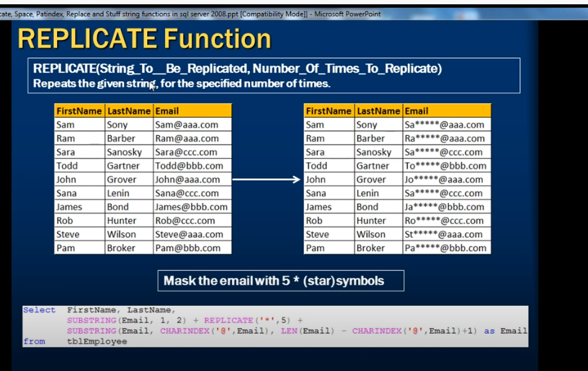

Replicate( String to be replicated, number of times)

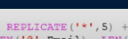

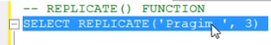

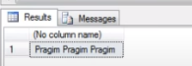

They don’t reveal full email id, they masks

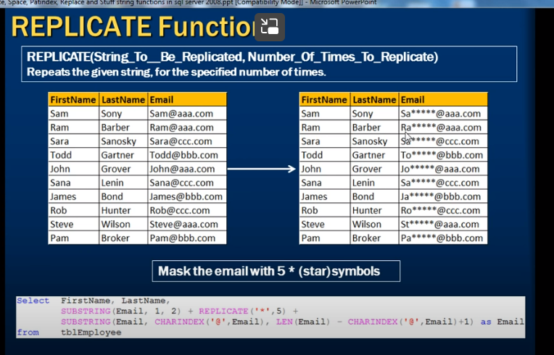

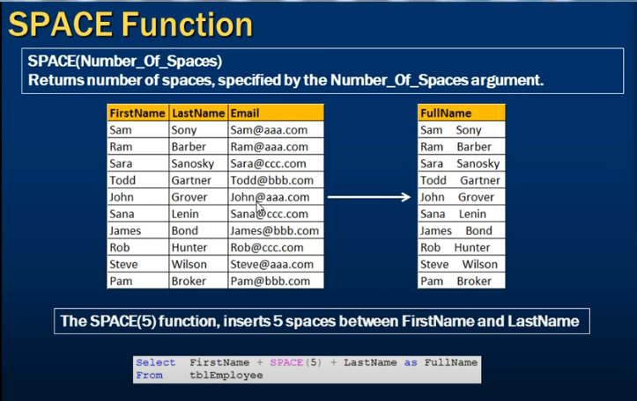

Spaces(5)

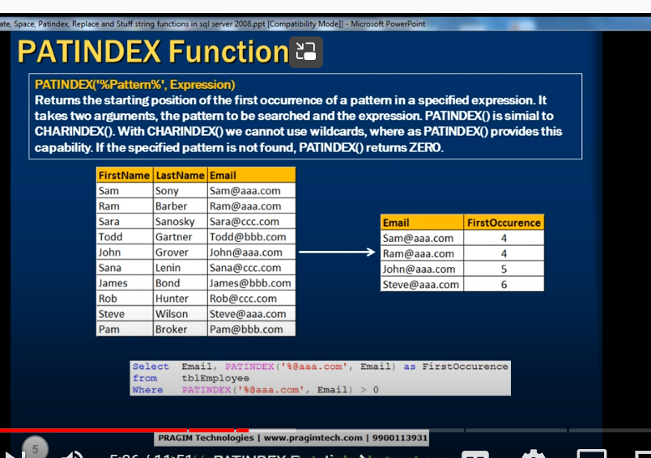

Patindex(pattern u want, string)

Similar to char index

Finding start index of @aaa.com

Before that we don’t care number

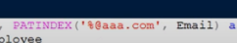

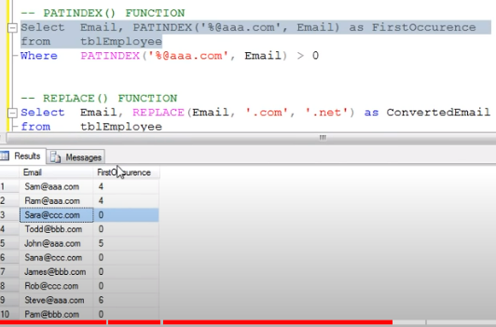

It only returns only if the pattern matches

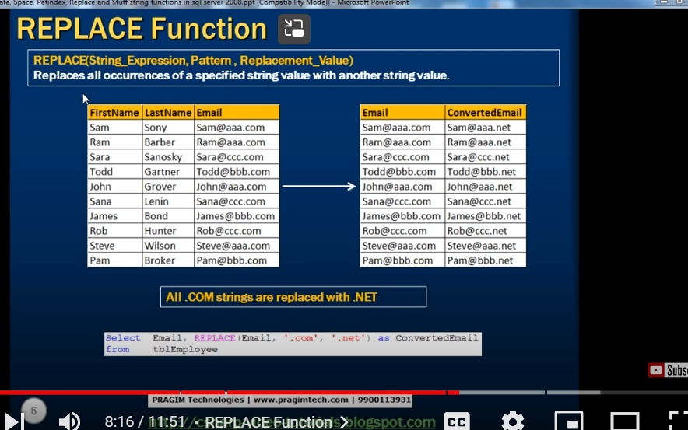

Replaces all occurrences with specified string

**Replace(string, pattern, replacement value)**

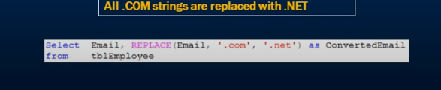

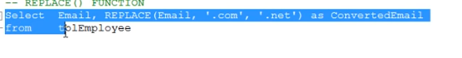

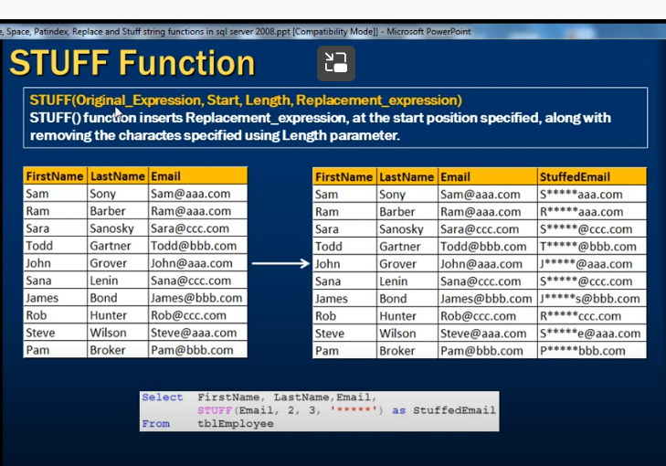

Stuff(string/coulumnname, start index, number of words, stuff words)

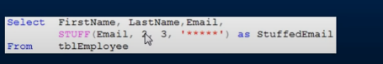

**Cast and Convert functions in SQL Server Part 28**

Convert one data type to other

Cast and convert

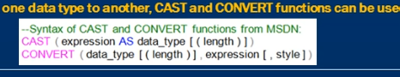

Cast(columnname as data_type)

Convert (datatype, columnname, style)



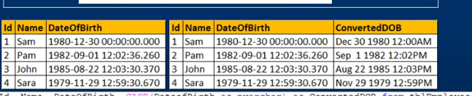

Length is optional

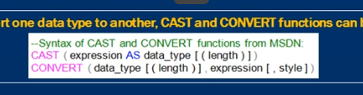

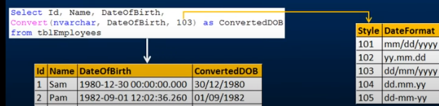

Style codes will be there

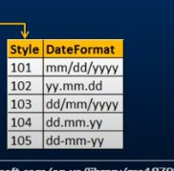

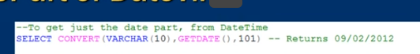

In sql server 2005 datetime – data type only there

2008 has

Datetime

date

time datatypes



Style will work only when we are converting into varchar

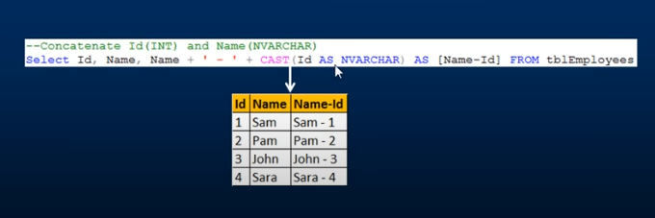

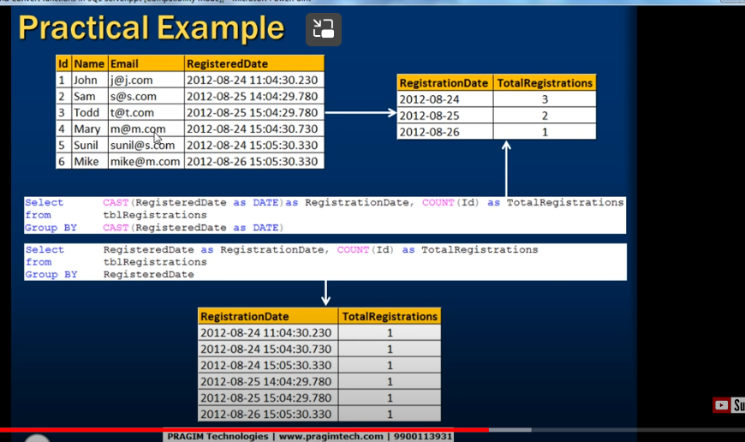

w 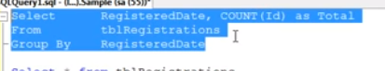

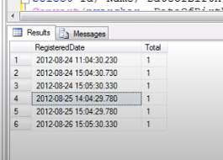

We got time and date

If we want just by date

Convert

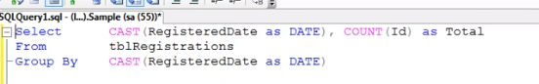

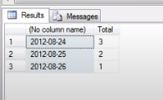

Diff between cast and convert

Cast : ansii standard – it can be used any databases

Convert is specific to sql server

**Mathematical functions in sql server**

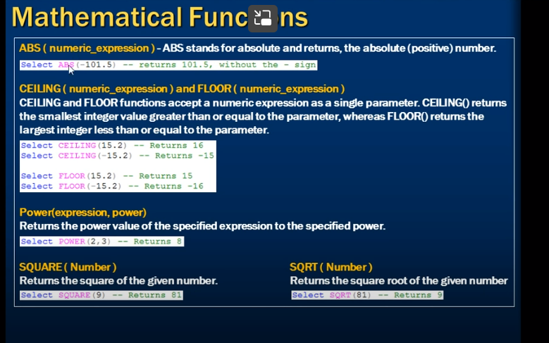

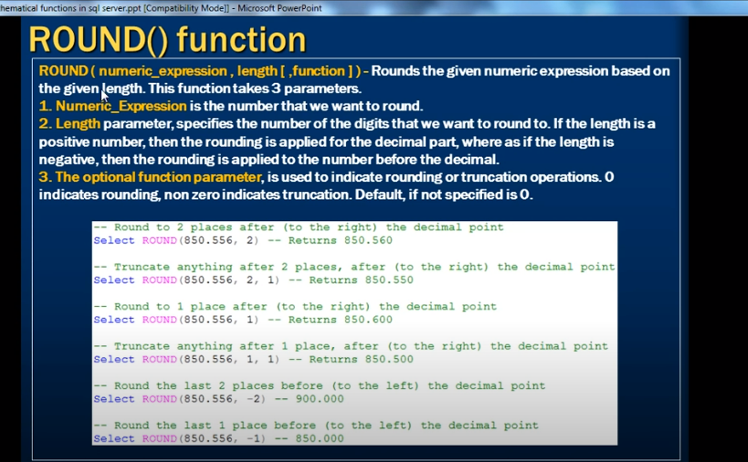

Round (that number that we want to round, how many decimal places to round)

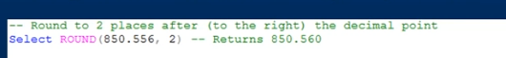

Whether to round or truncate

Default 0 (third parameter) – round

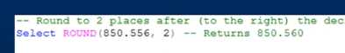

If we mentioned 3rd parameter as 1 or non zero – means ignore(truncate)



Ignore and returns 0

**Scalar user defined functions in sql server Part 30**

System Built in functions”:-scalar

Date functions

String function

Mathematical functions

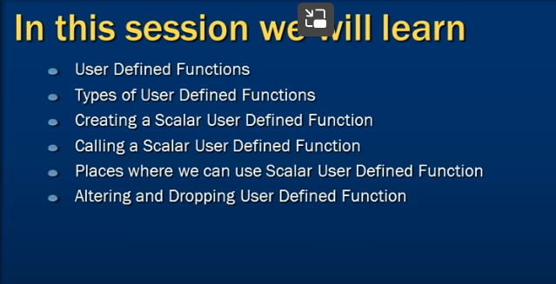

User defined function(UDF) -types

Scalar functions

Inline multi table functions-

Function has capability of taking some parameter and do process and return some values

Some functions doent require parameters

Function should always return value

Scalar function :

Scalar function can take zero to any parameters and returns a acalar value



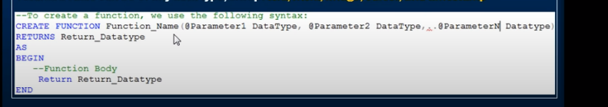

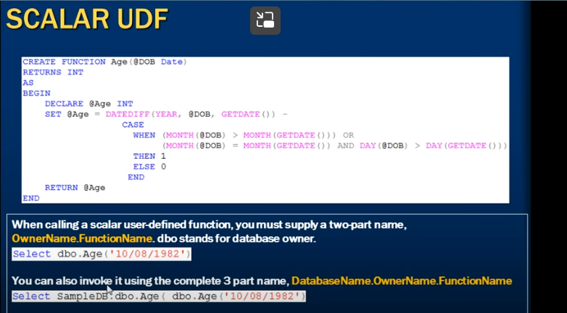

Subtracting

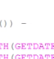

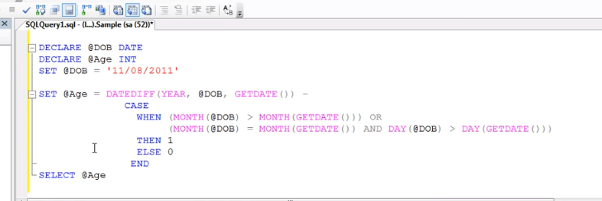

How to make above code as function

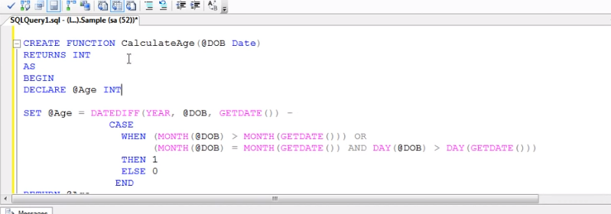

Scalar function since it returns one value

Now calling or invoke functions :

**Select databaseowner. function name (parameters)**





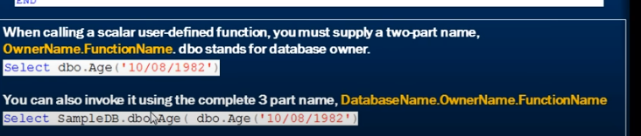

We can use scalar functions in select statements



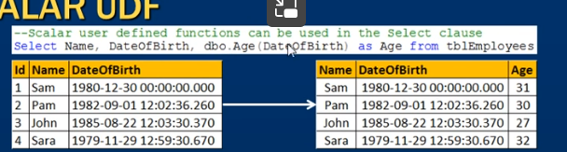

We can also use scalar function in where clause

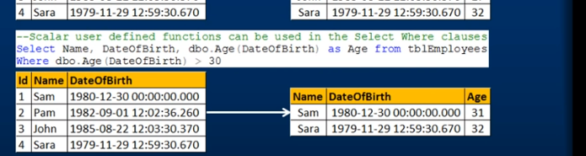

We cant used stored procedure in select and where



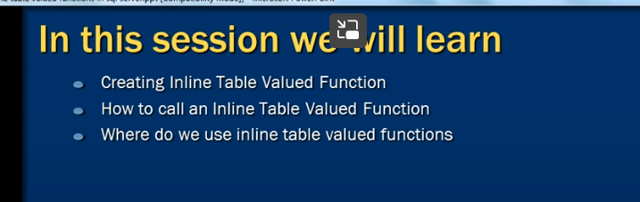

Returns a table

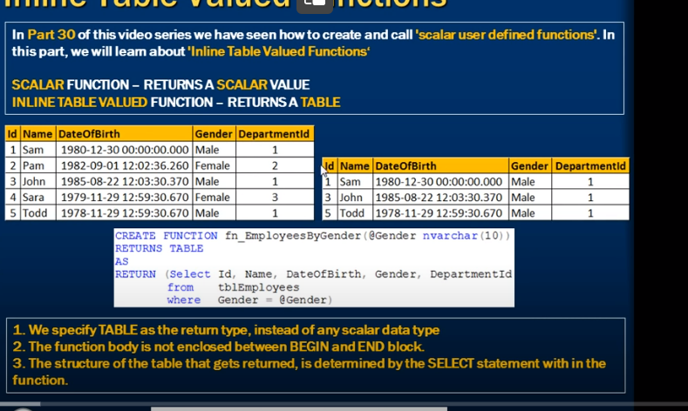

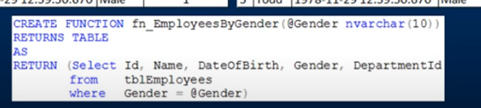

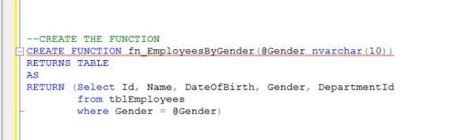

Calling





We can also use where clause

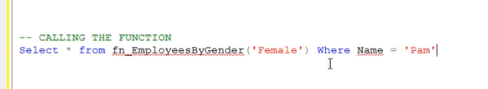

Treating inline function as table

It can be used for **parameterized views(** we can use inline table functions in place of parameterized views)

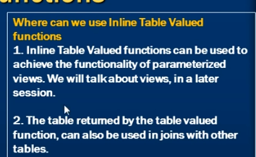

We can be used in joins along with other table

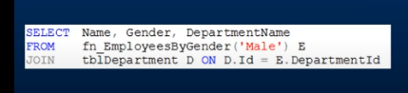

**Multi statement table valued functions in sql server Part 32**

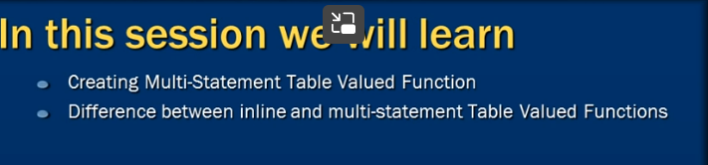

Similar to inline table functions

Inline table valued function: **doent take parameters**

**Return will not have structure of table**

Doent have **beign and end**

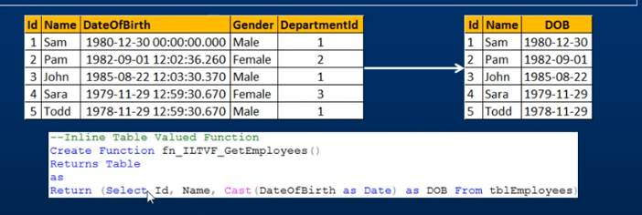

Multi statement table valued function

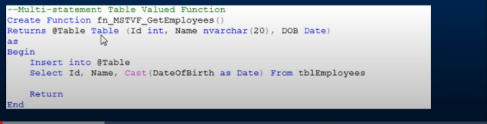

We specify structure of table

Parameters

Bigin and end

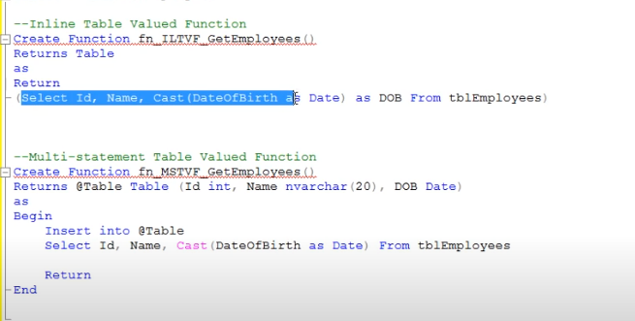

Calling function name

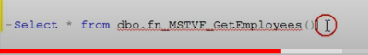

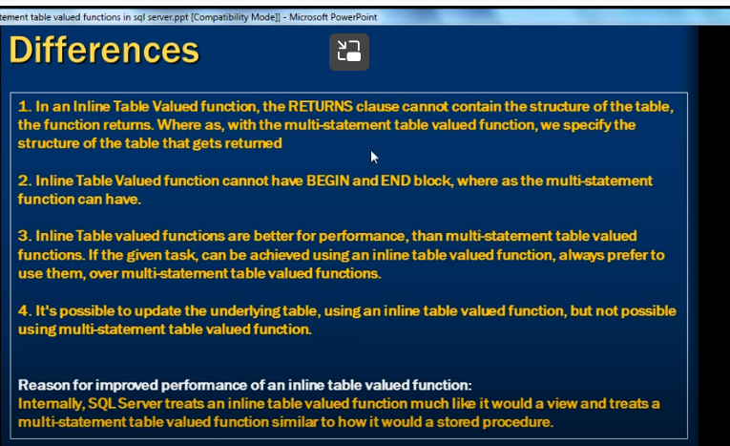

Inline table valued function : better for performance

--

We can update underlying table using inline but not through multi statement

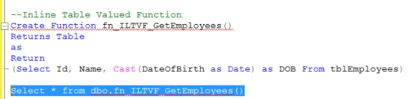

We are calling function like a table

We can edit and update data using function

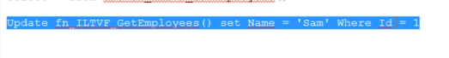

This will get updated

We cant use update statement with multi statement valued function

**Important concepts related to functions in sql**

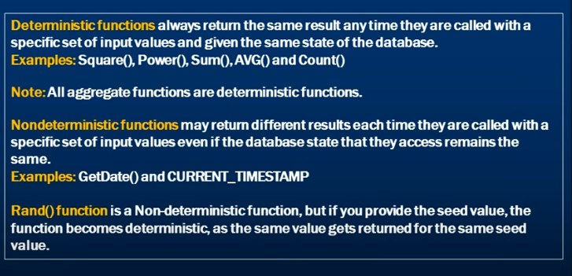

Rand behave like deterministic and non deterministic function

Rand (with seed value 1)== deterministic

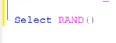above is rand without seed

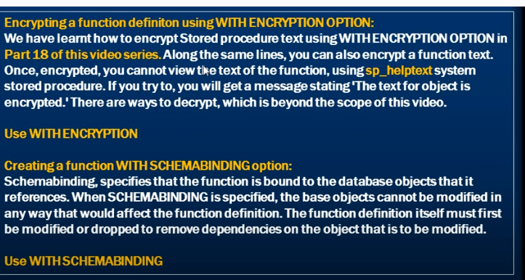

Encryption function is same like encrypting procedure

Write a function

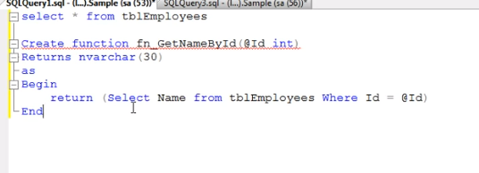



If I want to see definition of function

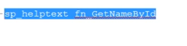

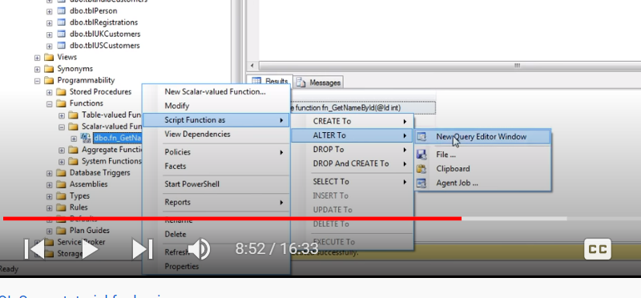

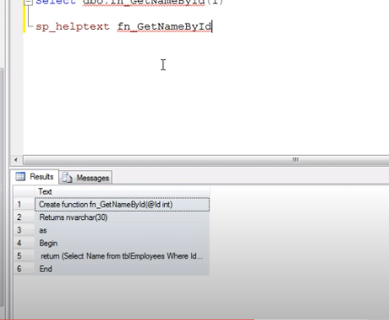

If we don’t want to see user to see text

We can encrypt while creating function

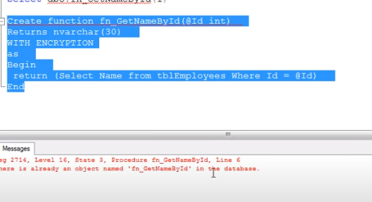

**Schema binding a function;**

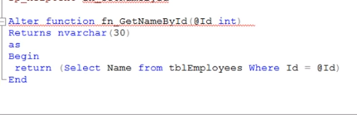

This function is depends on tbltable

That’s y when we are alling function we will use database object

When I delete table

When we try to exeute function gets fails as table got deleted

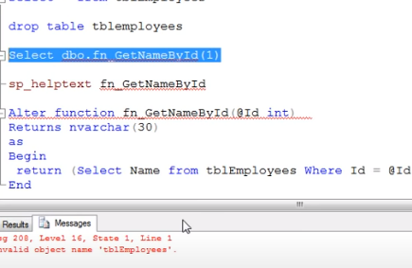

Can we prevent

To prevent this scheme building

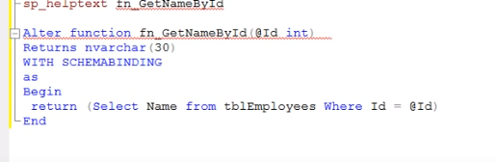

Below also gets failed as we need to specify both dbo.tbleemployee

Now if we try to drop table – we cant

**Temporary tables in SQL Server Part 34**

**Permanent table**

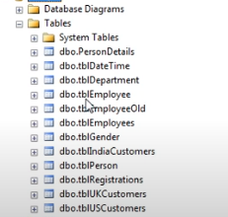

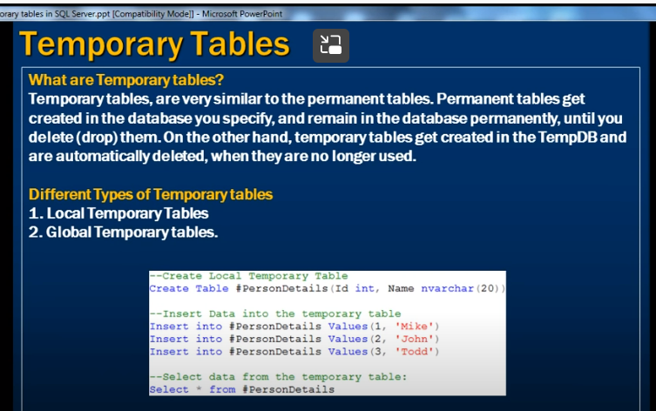

Temporary table get created in tempdb

Automatically deleted when no longer use

Tocreate temporary table

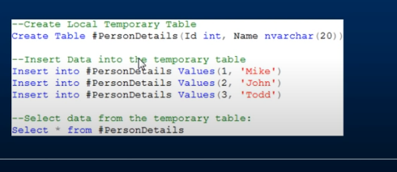

# Infront of table name

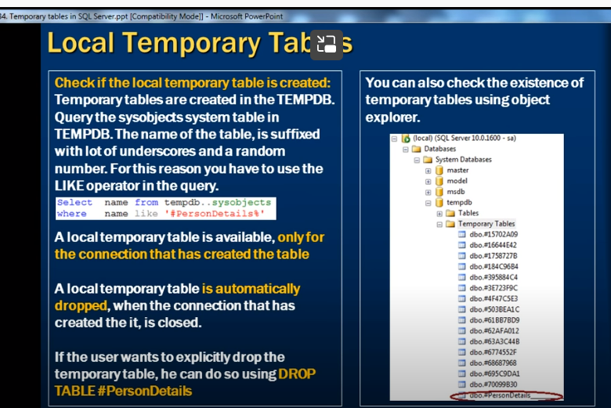

How do I check if local temporary table created or not

Expand system databases

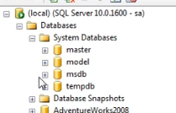

We can see tempdb

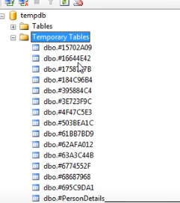

Other way

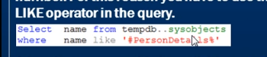

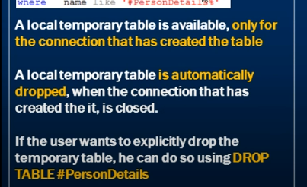

New query window is 1st connection – if we created temporary tablem in that window is called connection

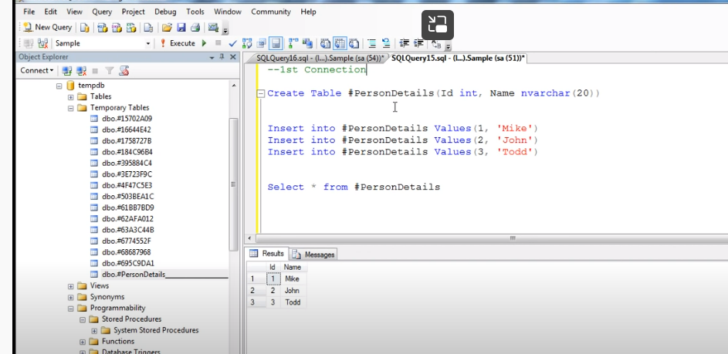

Local table can access only available in that connection window

--

If we open another query window try to access that table – cant get table

--

Once we close 1st connection window automatically drops the table

--

We can also do by using drop



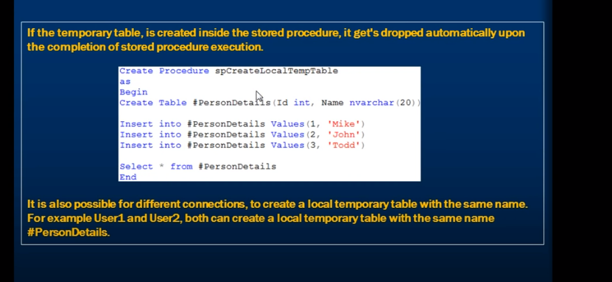

If we create temp table as a part of stored procedure

That temp table gets dropped upon execution of stored procedure

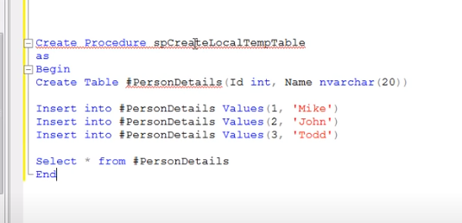

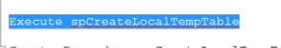

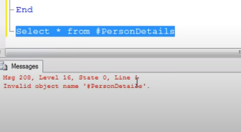

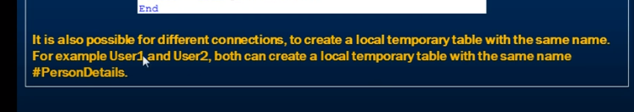

Diff connection can create diff temp tables with same name

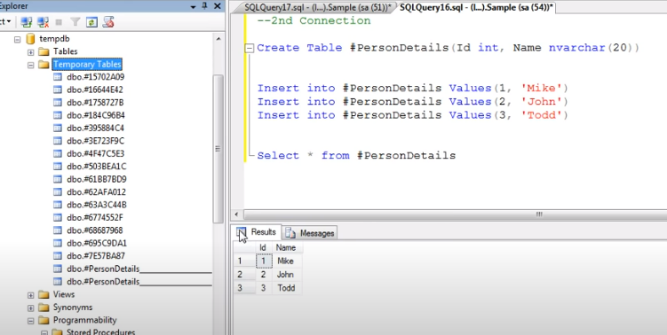

2 person details

But diff random numbers

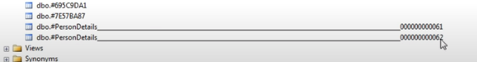

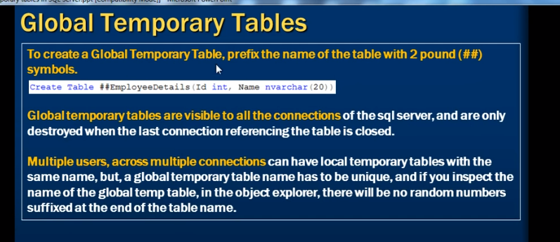

Global table prefix 2 # signs

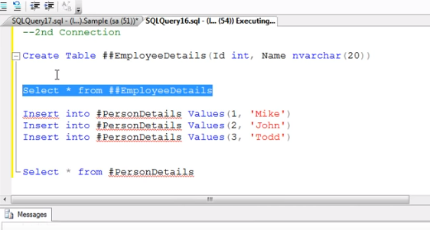

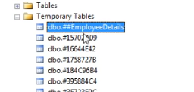

They are visible in all connections

Only destroyed only when last reference window closed

Global temp table must have unique name

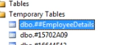

It hasn’t have any random number

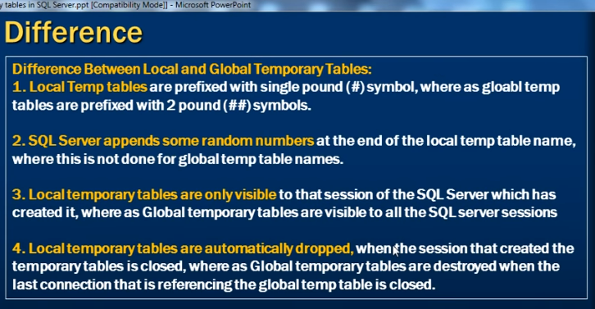

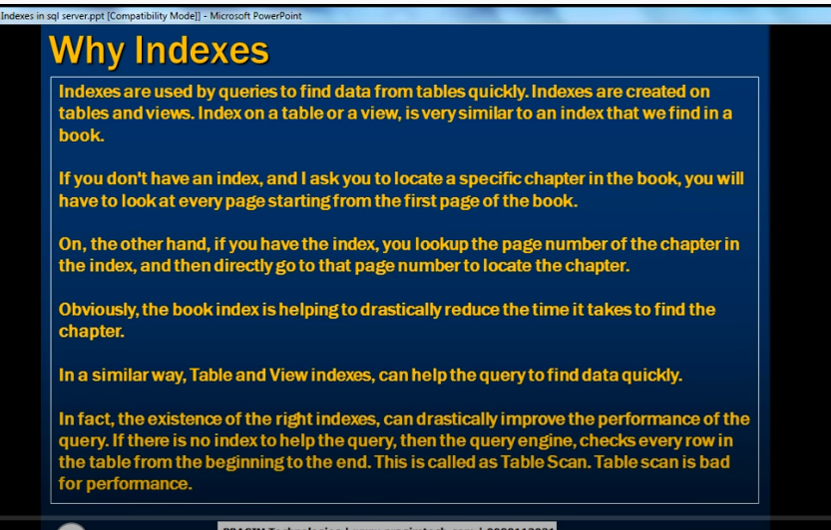

Indexes: used to find data from table quickly

We can create index On tables and view

Same like book

To find data quickly

Improve performance of query

Table scan bad in performance

Without index is like table scan

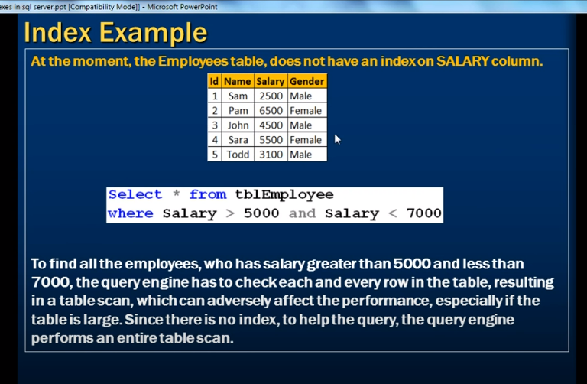

If salary has no index

If salary is not arranged

Then we need to see every row of salary

Table scan happen if table has no right index

--

Create index



IX=index

_table

_column on which we are creating index

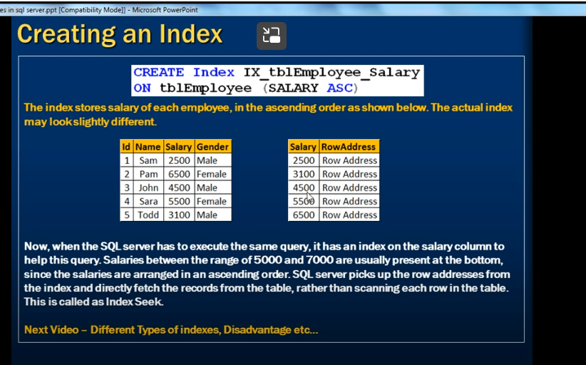

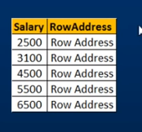

Salary will be assigned row address / hash address

It seeks the index , based on address it will go that particular row rather than scanning entire table

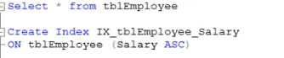

To find all indexes in a table

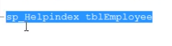

Drop index



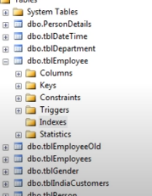

We can also graphically creates index

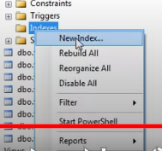

**Clustered and nonclustered indexes in sql server**

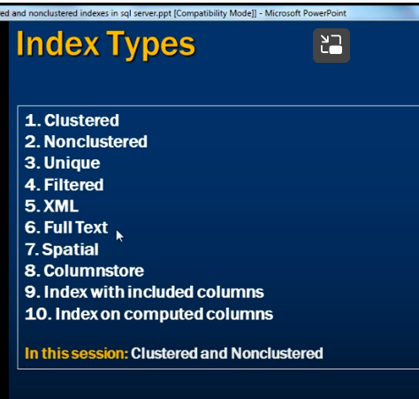

Clustered index

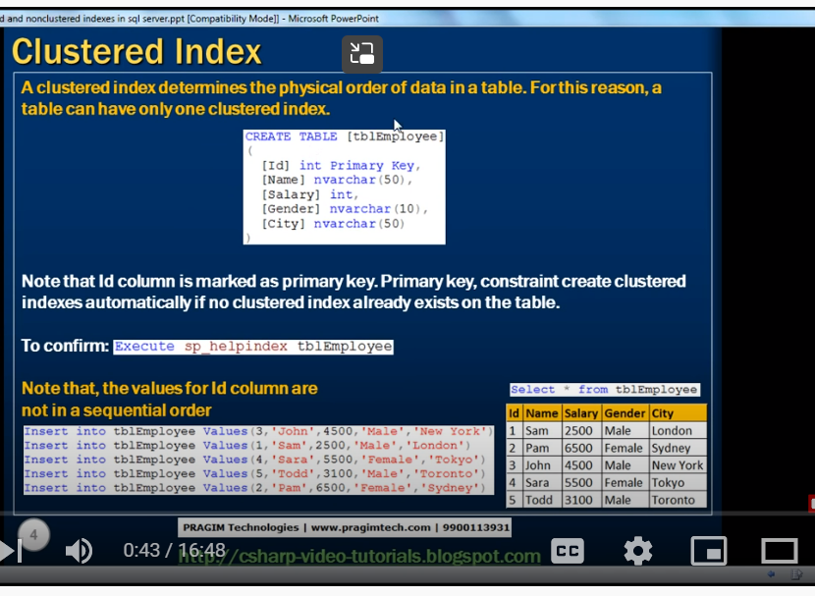

Cluster index is physical order of data

A table can have only one cluster index

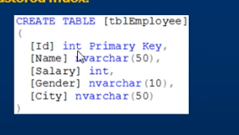

Primary key automatically creates cluster index on top of it

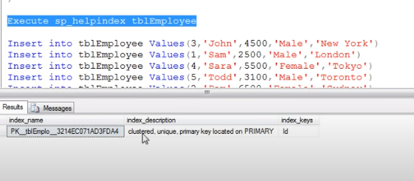

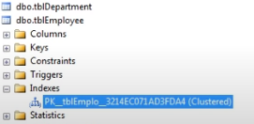

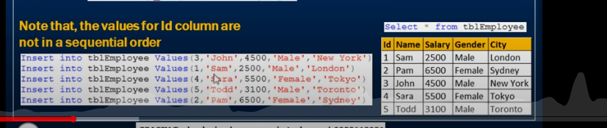

However I insert it automatically rearrange data based on primary key

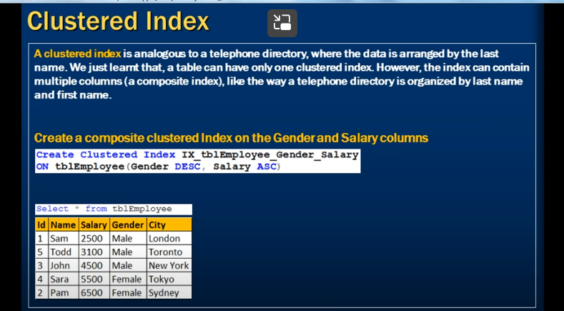

Like telephone directory – numbers arranged acc last name

--

A table can have only one cluster index

But cluster index may have have more than one column

If a cluster index has multiple columns called composite columns

(a non cluster index can also have many columns called non cluster composite cluster index)

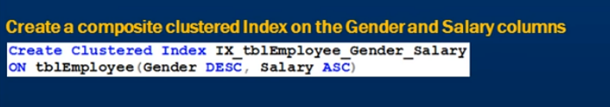

First it orders as per gender then by salary

Since the table has already cluster index on primary key (is ID)

First we need to drop index

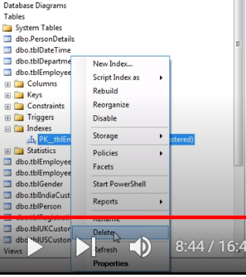

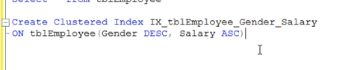

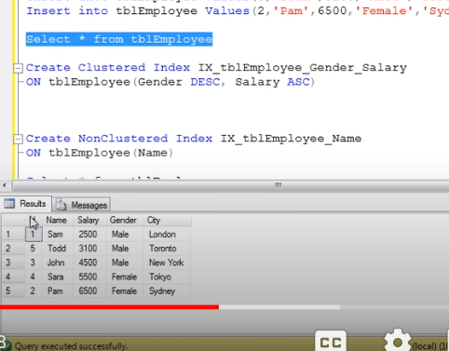

Now its arranged as per gender then on salary

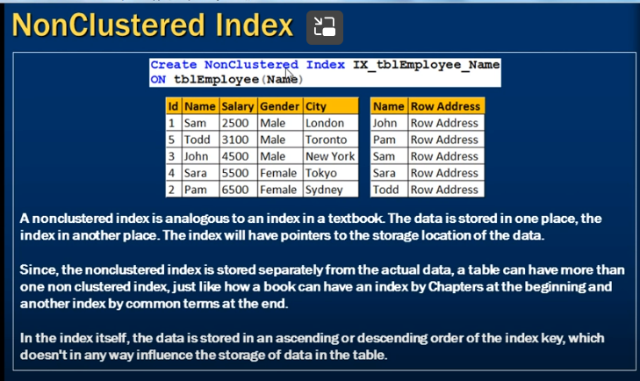

Non cluster index analogues to text book

Index stored at one place and data stored separately

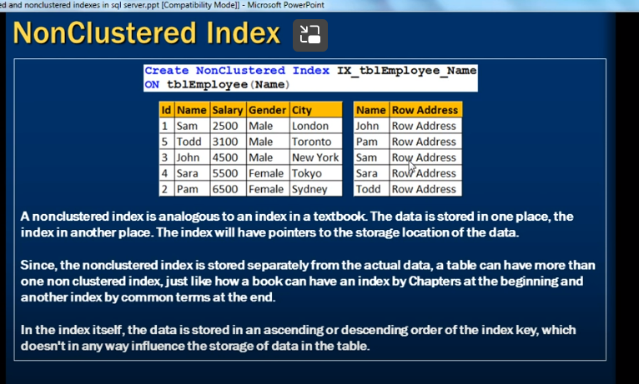

As per names

A table can have more than one index

It will not influence how data get stored in table like cluster index

Difference between cluster and non cluster index

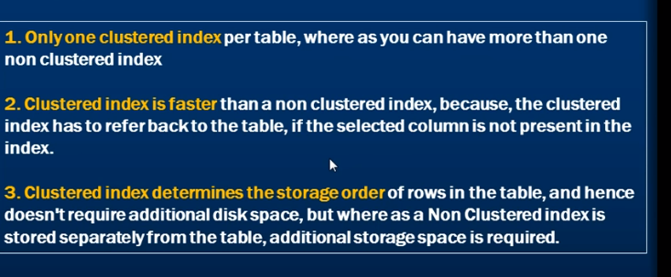

Since index stored separately non cluster index takes much time

--

Clustered – doent require additional disk place

**Unique and Non Unique Indexes in sql**

Unique index : enforce uniqueness

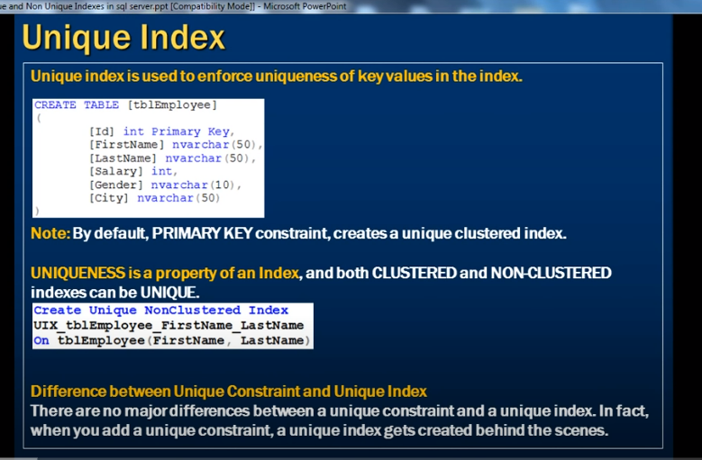

Id marked primary: default it is unique cluster index ‘

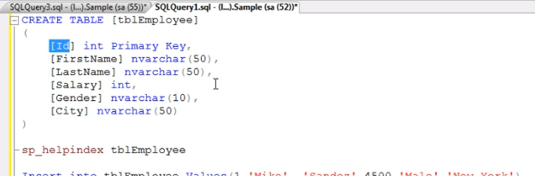

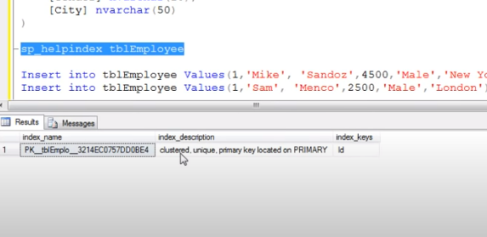

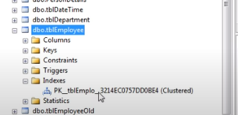

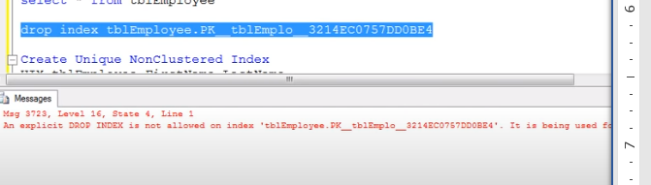

We cant drop as primary key automatically creates unique cluster index

When we delete cluster index from object explorer it automatically drops primary key

--

If we want to create unique non cluster index

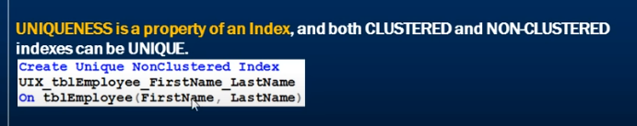



Diff between unique ey and unique constraint :

Unique key constraints:

Uniqueness to column

When we add unique constrain unique key gets created at the back

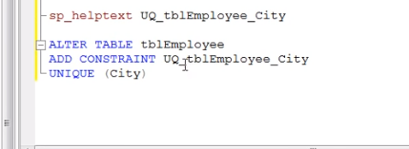

Along with constraints we can use

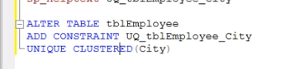

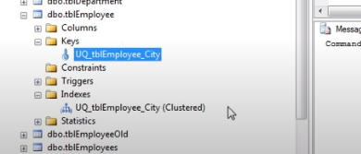

When should we create unique index :

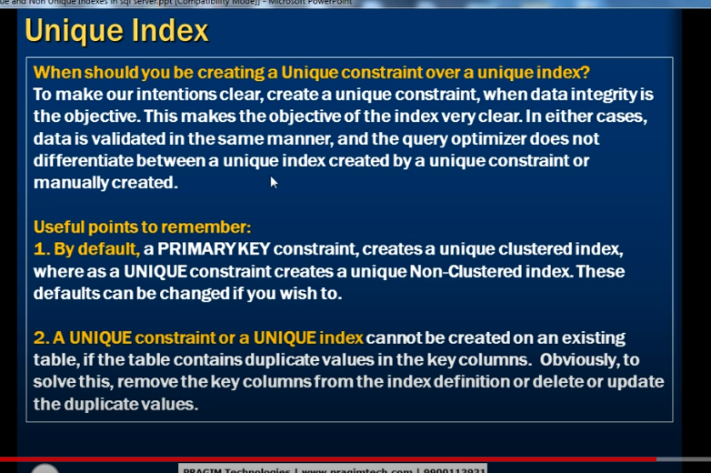

If column has duplicate values cant make it as unique constraints or index

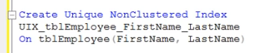

**Advantages and disadvantages of indexes in sql server**

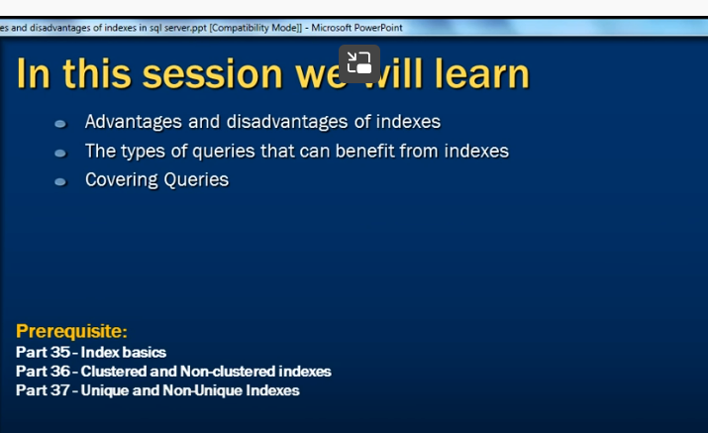

Advantages :

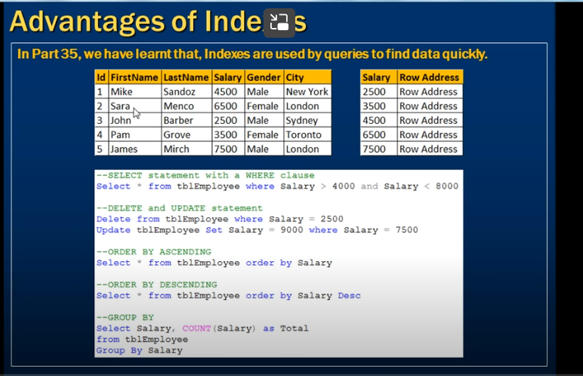

Salary will be arranged ascending order when we create index

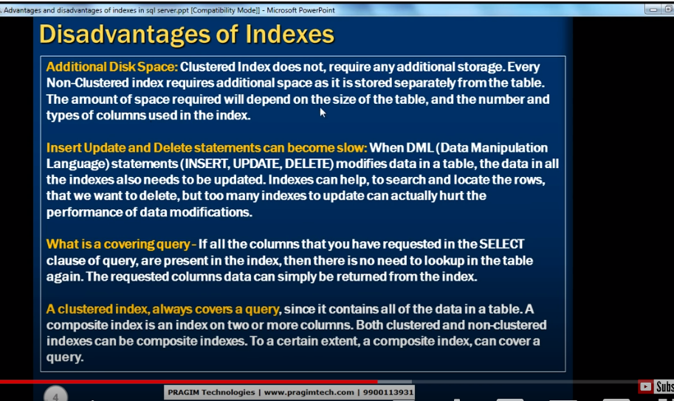

Insert, update , delete can be slow if the tables are huge and too many indexes

When we deleting record in tables will get deleted in index as well that indexex should be modified

--

Covering query: (all columns we specified in select statement (if that column is not in index) it must be look up for those columns from index ), if all columns in select list in index called covering index

Cluster index : always cover a query

Select * from table where id =5

Id covers in index